Market Study in FSM

A rapid survey of local markets, domestic supply chain and support networks.

**By Konrad Englberger and Olivier Wortel**

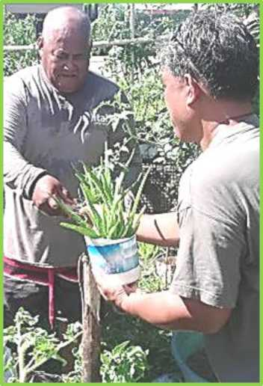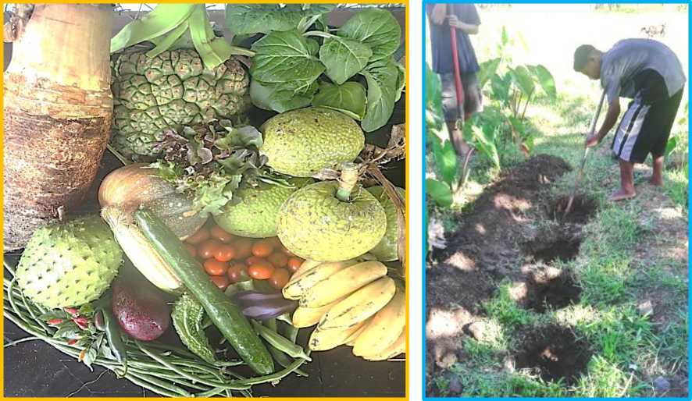

July 2019

This Study was funded by the International Fund for Agricultural Development (IFAD) and supported by  
the market owners, farmers, NGOs and government stakeholders who participated in this study.

Acronyms and Abbreviations

|  |  |
| --- | --- |
| AU | Agriculture Unit |
| COM | College of Micronesia |
| CRE | Cooperative Research and Extension |
| CWC | Chuuk Women’s Council |
| CRB | Coconut Rhinoceros Beetle |
| CTF | Compact Trust Fund |
| DFAT | Australian Department of Foreign Affairs and Trade |
| DREA | Department of Resources and Economic Affairs |
| EPA | Environmental Protection Agency |
| EU | European Union |
| FAO | Food and Agriculture Organization of the United Nations |
| FSM | Federated States of Micronesia |
| GAFSP | Global Agriculture and Food Security Program |
| GDP | Gross Domestic Product |
| HIES | Household Income and Expenditure Survey |
| IACT | Increase Agricultural Commodities Trade |
| IFAD | International Fund for Agricultural Development |
| IMF | International Monetary Fund |
| LFA | Lelu Farmers Association |
| NAIP | National Agriculture and Investment Plan |
| NCD | Non-Communicable Disease |
| NGO | Non-Government Organization |
| NRCS | Nature Resource Conservation Service |
| PIC | Pacific Island Country |
| R&D | FSM Department of Resources and Development |
| RMI | Republic of the Marshall Islands |
| PFA | Pohnpei Farmers Association |
| SPC | Secretariat of the Pacific Community |
| TNC | The Nature Conservancy |
| USA | United States of America |
| USD | United States Dollar |
| YFA | Yap Farmers Association |
| WFK | Women in Farming Kosrae |
| WHO | World Health Organization |

Table of Contents

1. **Background of Market Study 4**
2. **FSM Policy Framework and Scope of Work 4**
3. **Introduction 5**
4. **FSM Information** 6
   1. Quick Overview of Markets in FSM 6
   2. Exports of Agricultural Products 2017 13
   3. Exports of Pelagic Fish 13
   4. Exports of Reef Fish 14
   5. Imports of Agricultural Products 14
   6. Household Participation and Income Generation from Agricultural Activities 16
   7. Biosecurity 16
   8. Agricultural Production 17
   9. Agricultural Census 18
   10. FAO TCO 3601 Project 18
   11. Development of Coconut Processing for Export Markets 18
   12. Poverty Profile of the FSM 19
5. **Pohnpei 19**
   1. Pohnpei and Markets 19
   2. Reef Fish 19
   3. Pohnpei Farmers Association 20
   4. Agricultural Production 20
   5. Farmers Market 21
   6. Farmers Interview in Pohnpei 21
   7. Farm Input Supply in Pohnpei 21
   8. Socioeconomic analysis of agroforestry and home gardens in Pohnpei 21
6. **Yap 22**
   1. Markets in Yap 22
   2. Farming and Supply Chain in Yap 22
   3. FAO TCP 3601 Food Security and Strengthening Farmers Association 22
   4. Yap Farmers Association 23
   5. Interview with Chinese Farm Manager 23
   6. Interview with Bangladesh Farmer 23
7. **Chuuk 23**
   1. Markets in Chuuk 23
   2. Statistics on Exports of Agricultural Products from Chuuk to Guam 24
   3. Reef and Pelagic Fish 24
   4. Interview with a farmer from the Lagoon Island of Fefan 24
   5. College of Micronesia, Cooperative Research and Extension 25
   6. Chuuk Women’s Council 25
   7. Agricultural Supplies in Chuuk 25
8. **Kosrae 25**
   1. Abstract 25
   2. Interview with FSM Ambassador to China 26
   3. Farming and Supply Chain in Kosrae 27
   4. Sunrise Market 27
   5. RJ Store and Finaunpes Farms 28
   6. Wawa Chips 28
   7. PMW Farm and Store 29
   8. Lelu Farmers Association 30
   9. Women in Farming Kosrae 30
   10. Department of Resources and Economic Development 30
   11. Farm Input Supply in Kosrae 31
9. **Stakeholders Consulted 31**
   1. Pohnpei 31
   2. Yap 32
   3. Chuuk 32
   4. Kosrae 33
10. **Reports Sighted 34**

**Tables**

1. Summary of estimated sales (retail prices) of fruits, vegetables and fish in 2019 8
2. Value in USD of Agricultural Products Sold at FSM Markets Surveyed in July 2019 9
3. Exports of Agricultural Products for FSM in 2017 13
4. Imports of Agricultural Products for FSM in 2017 14
5. Value in USD of Kosrae Agricultural Exports to RMI, 2011-2018 29

**Annexes 35**

1. Kolonia, Pohnpei Market Survey Conducted in July 2019 35
2. Yap Market Survey July 2019 41
3. Chuuk Markets Monthly Quantities 2019 45
4. Kosrae Market Survey 2019 52
5. Timesheet and Activities for Konrad Englberger 55
6. Daily Activity Sheet for Olivier Wortel 57
7. Photos 63
8. Background of Market Study

On 14th March 2019 Global Agriculture and Food Security Program (GAFSP) issued a special call for proposals for funding for least developed and fragile and conflict affected countries. The World Bank classifies 24 countries in this category, of which five are in the Pacific: FSM, RMI, Kiribati, Solomon Islands and Tuvalu. The four North Pacific countries (FSM, RMI, Kiribati and Tuvalu) have agreed to submit a joint multi­country proposal for GAFSP funding. The four North Pacific countries have also requested IFAD technical support to prepare an application for GAFSP funding under the current call, and if successful, to support project implementation in the role of Supervising Entity. The proposals, to be submitted by 10 September 2019, are expected to be at pre-appraisal stage. To support the proposal preparation process IFAD and FAO convened at four-day workshop in Tarawa, Kiribati from 20th to 23rd May 2019 for preliminary consultations with the four participating countries. The meeting was attended by delegates from FSM, RMI, Kiribati and Tuvalu; as well as representatives of FAO, IFAD and the Australian Department of Foreign Affairs and Trade (DFAT).

1. FSM Policy Framework and Scope of Work

FSM has overarching national development plans which recognise the importance of agriculture and fishing in rural livelihoods and food/ nutrition security. They also have well developed policies and plans for climate change adaptation and mitigation, although many of these are un-funded as yet. However, several of the four countries do not have comprehensive and current agriculture and food security sector strategies, although some are in the process of preparing or updating such plans. None of the countries has a National Agricultural Investment Plan (NAIP). The current status of sectoral policies and development plans is as follows:

* FSM Agriculture Policy 2012-2016
* FSM Agriculture Policy 2012-2016 Review (July 2015)

The terms of reference for the GAFSP project design mission recognise that the lack of a strong policy and strategic framework and investment plans for the agricultural sector needs to be addressed under Part 1 of the GAFSP proposal. The consultations which provide a foundation for the project design will initiate the process of developing, strengthening or updating sectoral policies, strategies and investment plans, to be completed during the inception period of the proposed GAFSP-funded project.

The Scope of Work for the FSM market study, includes, but is not limited to:

* A rapid scan of current *roles and scope of local private sector actors* engaged in the food systems, and the *capabilities of civil society and Government* to implement resilience and livelihoods interventions in the States of Pohnpei, Chuuk, Yap and Kosrae;
* An assessment of needed support to *food systems and enabling environment*, to ensure farm and processing investments are responsive/competitive for markets; and,
* *A rapid appraisal of local food markets* in the FSM as well as preparation of *preliminary farm models*, to identify scalable opportunities for best-bet commodities, and for production, availability and affordability of highly nutritious local food for domestic markets (in particular community-based, low-tech production/consumption approach, and other technical options for transforming agriculture towards nutrition with low-tech solutions.

1. Introduction

The Federated States of Micronesia (FSM) consists of 607 islands, atolls and islets, spread across 2,600,000 square kilometers of the Western Pacific Ocean. It is divided in to four states - from east to west, Kosrae, Pohnpei, Chuuk and Yap. The population of around 103,000 resides on 65 islands. The national capital, Palikir, is located on the island of Pohnpei. The landform of FSM varies from mountainous islands with volcanic outcroppings to low coral atolls. The climate is tropical with heavy year-round rainfall especially in the eastern islands of Kosrae and Pohnpei. The nation is located on the southern edge of the typhoon belt and occasionally sustains severe damage, including landslides.

The country has a close relationship with the United States of America through the Compact of Free Association through which substantial funds are provided for the government, but transfers to the FSM are steadily declining and scheduled to cease in 2023.Thereafter, the FSM is expected to complement its domestic revenues with income from its Compact Trust Fund (CTF) and other savings. Therefore, achieving long­term budgetary self-reliance is becoming more urgent as 2023 approaches.

The structure of the FSM economy has changed little over the last decade. The share of the public sector in GDP stands at 38 percent, with the private sector at 22 percent and the household at 31 percent**[1]**. Whilst the outlook for economic growth remains heavily dependent on public sector spending, particularly on construction activities, declining public sector demand from Compact sector grant reduction is expected to reduce economic growth in the short to medium term. Weak economic performance over recent years is reflected in a decline in living standards and out-migration**[2]**.

The trade account of the balance of payments runs a significant deficit reflecting the excess of imports over exports (Figure 1). Although strong fish exports contributed to the small decline in the trade deficit in 2012, the current account deficit is projected to stay at around 10 percent of GDP, which is financed by the inflow of official transfers3.

***Promotion of local products and consumption of nutritious local foods will play a critical part in the battle against NCDs. Such preventive NCD measures would result in significant cost savings to individuals, the health budget and the economy, thereby constituting a fiscally responsible investment of public resources.***

According to the Report FSM (Pohnpei) NCD Risk Factor Steps Report Printed in 2008 by WHO: Noncommunicable Diseases (NCDs) are the leading causes of death, accounting for approximately 75% of deaths annually in Pacific island countries and areas. 73% of the population in Pohnpei are overweight and 32% are diabetic. The numbers are not dissimilar for the other FSM states.

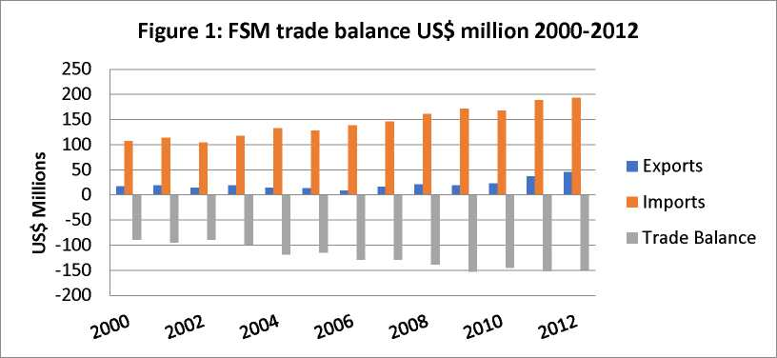

The above information is from the Report on Policy measures to increase local food supply and improve food security in the Federated States of Micronesia, November 2014, FAO Sub regional Office

1. FSM Information

FSM Population (2010): 102,843

Land Mass: 273.5 sq. ml

Islands: 607

Inhabited Islands: 65

Trade Deficiency: (2017) 137,438

Inflation Rate (2017): 0.02

* 1. Quick overview of Markets in FSM

Pohnpei has 3 major vegetable markets, about 20 small stores selling mainly cooked food and 5 large commercial shopping centers selling imported produce from the USA. In Pohnpei there is a fluctuation on the availability of fresh produce, some of the vegetables are not always available. There is room for farmers to produce more vegetables in Pohnpei.

Yap has one Supermarket selling local produce, 8 vegetable markets and 3 Fish markets. The supply with local vegetables in Yap is very good, some farmers were complaining that there are not able to sell there produce all the time.

Chuuk has 16 Roadside Markets, some only sell Betel Nut and cooked/pounded food, other’s sell vegetables and fish. In Chuuk there is often a shortage of some of the fresh vegetables like cucumber, eggplants, some vegetables like Chinese Cabbage, leafy vegetables Keng Kong), tomatoes and others are not available. There is room to produce more local vegetables. It was also noted that the prices for local vegetables are very high, sometimes more than twice as high compared to the other FSM States. The information on pounded breadfruit in Chuuk is very high, it is questionable if the seasonality was considered in the estimation. Some of the products are sold at the markets and taken (re­exported) by aircraft passengers to Guam or Hawaii.

Kosrae has 20 formally registered Local Markets[3]. It is not known if all of them are continuing to operate, or at what level, however this number is consistent over the last 20 years and indicates a generally thriving domestic agricultural market and demand for such products. There are approximately 3-5 such markets and stores selling agricultural and marine products which are the largest in any given year, purchasing produce from other farmers as well as supplying their establishments with their own grown foods, generally with family affiliated green houses and farms. In addition, there is currently at least one monthly Farmers Market in the beachside community of Tafunsak[4]. All of the markets generally sell packaged cook foods[5] known as ‘take outs’, in particular Sunrise Market, which is situated in the government center of the island. There are four large stores selling imported produce from the USA. In Kosrae there is a fluctuation in the availability of fresh produce, and some of the vegetables are not always available. There is room for farmers to produce more locally, for both the domestic and export markets**[6]**.

The below Table provides information on local produce and fish available at the four FSM States. The data were provided by Market owners, most of the information is based on estimations. It is pleasing to see that large amounts of cooked food are sold in Pohnpei (231,330 pounds) and Chuuk 615,249 pounds) markets.

Table 1: Summary of estimated sales (retail prices) of fruits vegetables and fish vegetables for the 4 FSM States in 2019

|  |  |  |  |  |  |
| --- | --- | --- | --- | --- | --- |
|  | Fruits &  Vegetables US $ | Cooked Food | Marine  Products | Processed  Products | Total |
| Pohnpei | 229,956 | 240,000 | 1,273,386 |  | 1,743,342 |
| Chuuk | 1,046,616 | 345,020 | 3,406,000 |  | 4,797,636 |
| Yap | 1,102,487 | 12,767 | 368,164 |  | 1,483,418 |
| Kosrae | 212,241 | 93,970 | 7,740 | 88,680 | 402,631 |
| Total | 2,591,300, | 691,757 | 5,055,290 | 88,680 | 8,427,027 |

Table 2 below provides information on values in USD of local produce and fish sold at the four FSM States in 2019. The data were provided by Market owners, most of the information is based on estimations.

Table 2: Value in USD of Agricultural products sold at the FSM Markets Surveyed in July 2019

|  |  |  |  |  |  |  |  |  |
| --- | --- | --- | --- | --- | --- | --- | --- | --- |
|  | Pohnpei | | Chuuk | | Yap | | Kosrae | |
|  | Quantity lbs/year | Retail $/lbs | Quantity lbs./year | Retail $/lbs | Quantity lbs./year | Retail  $/lbs | Quantities lbs/year | Retail  $/lbs |
| Avocado | 1,800 | 2.00 |  |  | 151 | 1.25 |  |  |
| Banana fresh | 80,820 | 0.35­  0.65 |  |  | 22,920 | 0.60 | 35,529 | .60 |
| Banana cooking | 108,480 | 0.25­  0.30 |  |  | 7,704 | 0.55 |  |  |
| Bell Pepper | 900 | 2.50 |  |  |  |  | 4,640 | 2.75 |
| Yard Long Beans | 1,500 | 1.25­  1.50 |  |  | 9,072 | 1.25-2,00 | 3,330 | 1.50 |
| Bitter Gourd | 3,600 | 0.75 |  |  | 864 | 1.25 | 1,320 | 2.75 |
| Breadfruit | 12,240 | 0.50­  0.65 | 33,400 | 0.50 | 15,564 |  |  |  |
| Betel nut |  |  | 69,312 | 10.00 |  |  |  |  |
| Cassava | 4,800 | 0.75 |  |  | 1,800 | 0.50 |  |  |
| Cantaloupe |  |  |  |  | 384 | 1.90 | 6,480 | 2.00 |
| Chinese  Cabbage | 1,200 | 1.50 |  |  | 2,664 | 2.50 | 29,400 | 2.00 |
| Chili Pepper | 960 | 1.25­  150 |  |  | 2.472 | 2.50 | 5,350 | 1.50 |
| Cucumber | 21,600 | 1.25- | 83,529 | 1.50 | 42,151 | 1.00-1.25 | 23,760 | 1.50 |

|  |  |  |  |  |  |  |  |  |
| --- | --- | --- | --- | --- | --- | --- | --- | --- |
|  |  | 1.85 |  |  |  |  |  |  |
| Coconut drink  Per unit | 24,000 | 0.50­  0.65 |  |  | 29,400 | 0.65-1.00 | 3,300 | .50 |
| Coconut mature nut | 43,000 | 0.15 |  |  |  |  |  |  |
| Eggplant | 100 | 0.75 |  |  | 11,832 | 1.25 | 9,000 | 1.50 |
| Ginger | 1,020 | 2.00 |  |  | 420 | 4.50 |  |  |
| Lime/Lemon | 11,100 | 2.00 | 70,501 | 3,00 | 4,680 | 0.65-2.50 | 16,236 | 1.50 |
| Green onion |  |  |  |  | 3,600 | 3.00 |  |  |
| Mango | 7,200 | 0.50­  0.75 |  |  | 368 | 0.70 |  |  |
| Okra | 1,200 | 1.50 |  |  | 4,536 | 2.00-2.50 | 3,150 | 1.50 |
| Orange |  |  |  |  |  |  | 4,560 | 1.00 |
| Pumpkin | 7,500 | 1.00­  1.75 |  |  | 16,776 | 1,00 | 1,890 | 1.25 |
| Kalamansi | 5,880 | 1.50­  2.00 |  |  |  |  | 4,005 | 1.25 |
| Kangkong | 6,240 | 1.00 |  |  | 3,900 | 2.00 |  |  |
| Pandanus | 2,160 | 0.50­  0.75 |  |  |  |  |  |  |
| Soursop | 3,000 | 0.75 |  |  | 720 | 1.90 | 630 | 1.50 |
| Sugar cane | 1,080 | 0.75 |  |  |  |  |  |  |

|  |  |  |  |  |  |  |  |  |
| --- | --- | --- | --- | --- | --- | --- | --- | --- |
| Sweet Potato | 2,700 | 0.75­  1.50 |  |  | 60 | 1.90 |  |  |
| Spinach |  |  |  |  | 624 | 2.50 |  |  |
| Squash |  |  |  |  | 624 | 1.25 | 23,684 | 1.50 |
| Tangerine |  |  |  |  |  |  |  |  |
| Pineapple |  |  |  |  |  |  | 12,162 | 1.25 |
| Papaya |  |  |  |  |  |  | 2,268 | 1.00 |
| Taro soft  Colocasia | 5,400 | 0.75 |  |  | 17,400 | 0.75 | 4,500 | 1.25 |
| Taro Hawaii | 3,000 | 0.75 |  |  |  |  |  |  |
| Taro | 9,000 | .50 |  |  |  |  |  |  |
| Tomato | 40 | 2.00 |  |  |  |  |  |  |
| Yam | 24,300 | 1.25 |  |  |  |  |  |  |
| Watermelon | 5,400 | 0.75 |  |  | 22,632 | 1.00-1.25 | 5,220 | 1.50 |
| Tapioca/Manioc |  |  |  |  |  |  | 1,026 | 1.00 |
| Yungawa |  |  |  |  | 960 | 1.25 |  |  |
| Yapese lime |  |  |  |  | 3,690 | 2.50 |  |  |
| Mangrove Crab | 42,600 | 3.50­  5.50 |  |  |  |  | 15,156 | 3.00 |
| Fish Reef | 164,400 | 1.50­  1.75 | 1,080,480 | 1.75 | 190,622 | 1.50 | 5,040 | 1.50 |

|  |  |  |  |  |  |  |  |  |
| --- | --- | --- | --- | --- | --- | --- | --- | --- |
| Pelagic | 214,800 | 1.50­  1.75 | 707,180 | 2.00-2.25 | 177,542 | 1.75 |  |  |
| Lobster | 7,500 | 3.50 | 50,400 | 2.00 |  |  | 2,700 | 3.00 |
| Cooked Banana | 94,800 | 1.00 | 50,400 | .15-.40 | 7,704 |  | 19,875 | 1.25 |
| Cooke  Breadfruit | 80,160 | 1.00 | 479,040 | .35-0.75 |  |  |  |  |
| Pork |  |  |  |  | 2,400 | 2.95 | 10,800 | 3.00 |
| Cooked Taro | 51,000 | 1.00 | 185,800 | 0.50 | 23,400 | 2.00 | 10,800 | 3.00 |
| Cooked Yam | 14,400 | 1.00 |  |  |  |  |  |  |
| Shredded  Coconut |  |  |  |  |  |  | 21,000 | 5.00 |
| Shredded Taro |  |  |  |  |  |  | 14,700 | 5.00 |
| Shredded  Tapioca |  |  |  |  |  |  | 16,800 | 5.00 |
| Lime Juice 8oz |  |  |  |  |  |  | 17,280 | 4.00 |
| Kalamansi Juice |  |  |  |  |  |  | 4,200 | 5,00 (8 oz) |
| Chili sauce |  |  |  |  |  |  | 27,600 | 5.00 (8oz) |
| Salted Chili  Pepper S |  |  |  |  |  |  | 39,600 | 5.00 (8oz) |
| Coconut Oil |  |  |  |  |  |  | 26,100 | 5.00 (5 oz) |
| **TOTAL** | **1,068,180** |  | **2,810,042** |  | **627,166** |  | **433,091** |  |

* 1. Exports of Agricultural Products in 2017

The Table below shows that the total export value of Agricultural Products in 2017 for FSM was $ 6,451,536, the value for Betel nut from Yap and Pohnpei is $ 5,448,527- which is 84%. Cooked food from Chuuk with a value of $124,934. A major constraint for export is transportation, shipping products by air is very expensive and by sea it will take a long time for perishable products. Pohnpei and Kosrae used to export bananas to Guam, but due to the high air cargo rates the export has stopped. Kosrae is exporting some Agricultural products to Marshall Islands, a natural trading partner, but the amount of export has dropped significantly over the last three years[7]. Kosrae, with a small population, good soils and a surplus of arable land, should be doing everything it can to enhance its productive capacity in the Agriculture sector for export and trade to the neighboring islands of the Marshalls, Nauru and elsewhere.

The below information was provided by Mr. Jun Adolph, Statistics Specialist with the FSM Division of Statistics. The data are for 2017.

Table 3: Exports of Agricultural Products for FSM in 2017

|  |  |  |  |  |  |  |  |  |
| --- | --- | --- | --- | --- | --- | --- | --- | --- |
| **Product** | **Chuuk** | **Chuuk** | **Pohnpei** | **Pohnpei** | **Yap** | **Yap** | **Kosrae** | **Kosrae** |
|  | **Quantity Kg** | **Value $** | **Quantity kg** | **Value $** | **Quantity kg** | **Value $** | **Quantity Kg** | **Value $** |
| Copra | 629 | 4,982 | 47,863 | 18,948 | 92478 | 34,587 | 0 | 0 |
| Banana | 104 | 319 | 1,126 | 1,090 | 0 | 0 | 275 | 317 |
| Citrus | 0 | 0 | 174 | 648 | 0 | 0 | 808 | 1,493 |
| Kava | 0 | 0 | 6,2678 | 827,354 | 0 | 0 | 39 | 301 |
| Betel Nut | 14 | 75 | 105,777 | 698,127 | 215,927 | 4,750,400 | 4 | 8 |
| Piper Leaf | 0 | 0 | 600 | 13,199 | 6,645 | 65,786 | 0 | 0 |
| Root Crops | 344 | 945 | 2,937 | 3,764 | 990 | 2,634 | 231 | 469 |
| Cook Food | 20,673 | 124,934 | 0 | 0 | 3,200 | 8,520 | 0 | 0 |

* 1. Exports of Pelagic Fish

The Report cited below is by Gillett, R.D 2016: *Fisheries in the Economies of the Pacific Island Countries and Territories*, Published by SPC. It is stated that overall exports of tuna from FSM have decreased at an annual rate of 17.8% from 54.7 MM tons in 2010 to 20.6 MM tons in 2015. The 20.6 M in 2015 is mainly from re-exports. License fees collected from pelagic fishing was 19,937 MM in 1999 and has significantly increased over the years and was 62,571 MM in 2015.

* 1. Export of Reef fish

There are is no data available on the export of reef fish because it is mainly taken by people who travel to Guam or Hawaii to bring fish for family members or friends. It should not be underestimated the quantities are rather high. According to Chuuk statistics in 2018 was 15,027 pounds of reef fish exported to Guam.

* 1. Imports of Agricultural Products

The total import value for FSM in 2017 was 183.5 Million. According to the FSM Statistics. There are many items which could be produced locally, for import substitution like eggs and vegetables. Some of the vegetables only grow in temperate climate and cannot grown in the tropics, e.g. Cauliflower, potatoes and others. There are items which are of poor nutrition like sugary soda drinks which import value is almost $3 million. The following recommendation was made on the FAO Food Security Policy Measures Report*:*

The FSM Department of Health together with the FSM Deparment of Resources and Development (R&D)should lead the consultation with the FSM Deparment of Finance and Administration on the design and implementation of a ‘health excise’ on food (& beverage) products with a negative impact on NCDs, and the identification of priority programmes for facilitating improved access to healthier substitute propducts. This excise would focus on developing a watch list of food and beverage items for which a single 100g serve would contain more than 30% of the Recommended Daily Intake of total fat, salt and sugar for an average adult consumer; and subsequently applying at least a 20% ad valorem excise in order to increase the cost, and decrease the incentive to consume, those products identified as contributing to poor nutritional outcomes in FSM.

Table 4: Imports of Agricultural Products for FSM in 2017

|  |  |  |  |  |  |  |  |  |
| --- | --- | --- | --- | --- | --- | --- | --- | --- |
| **Product** | **Chuuk** | **Chuuk** | **Pohnpei** | **Pohnpei** | **Yap** | **Yap** | **Kosrae** | **Kosrae** |
| **Year**  **2017** | **Quantity kg** | **Value $** | **Quantity kg** | **Value $** | **Quantity kg** | **Value $** | **Quantity kg** | **Value $** |
| Fish |  | 9,567 |  | 549 |  | 12,960 |  | 19,121 |
| Eggs |  | 346,255 |  | 536,702 |  | 110,273 |  | 66,459 |

|  |  |  |  |  |  |  |  |  |
| --- | --- | --- | --- | --- | --- | --- | --- | --- |
| Citrus |  | 44,655 |  | 80,368 |  | 9,530 |  | 210 |
| Cauliflower  Cabbage Lettuce |  | 147,782 |  | 248,996 |  | 61,527 |  | 158,260 |
| Onion, Garlic |  | 131,828 |  | 150,213 |  | 64,938 |  | 32,948 |
| Potato |  | 22,676 |  | 52,260 |  |  |  | 16,740 |
| Fruits juice |  | 214,700 |  | 306,113 |  | 21,673 |  | 36,236 |
| Rice |  | 3,393,914 |  | 3,120,758 |  | 595,092 |  | 473,340 |
| Ramen |  | 663,069 |  | 1,584,695 |  | 456,801 |  | 236,382 |
| Biscuits, cakes |  | 863,520 |  | 1,732,029 |  | 494,684 |  | 350,387 |
| Flour |  | 587,353 |  | 501,924 |  | 101,802 |  | 46,021 |
| Canned meat |  | 1,416,678 |  | 1,682,175 |  | 638165 |  | 577,888 |
| Canned Fish |  | 1,596,319 |  | 972,309 |  | 470,800 |  | 155,620 |
| Sugar |  | 902,128 |  | 552,820 |  | 194,479 |  | 187,191 |
| Soft drinks |  | 944,253 |  | 933,795 |  | 745,079 |  | 392,102 |
| Animal feed |  | 22,520 |  | 1,318,983 |  | 105,356 |  | 67,087 |
| Fertilizer |  | 1,368 |  | 7,283 |  | 8,688 |  | 5,118 |

4 .6 Household Participation and Income Generation from Agricultural Activities for FSM in 2013/2014

* 3 in 5 households engaged in agricultural activities
* 20 mill USD for consumption, sold and gifted
* 32 mill USD Agricultural Products
* 28 mill USD Crops
* 4 mill Livestock USD

**Agriculture Crops Sold, Consumed or Gifted[8]**

* Sakau (Kava) 7.3 mill USD
* Banana 3.2 mill USD
* Coconut 1.3 mill USD
* Taro 4.5 mill USD
* Yam 2.4 mill USD
* Cassava 0.8 mill USD
* Breadfruit 4.2 mill USD
* Betel Nut 1.9 mill USD
* Other, Papaya Lime

4.7 Biosecurity

Biosecurity or Quarantine is very important for FSM and RMI, there are many pests and diseases in neighboring countries like Guam, Hawaii, and Palau which are not present in the FSM or RMI. Guam has the Coconut Rhinoceros Beetle CRB strain 2, and the Melon Fruit Fly, Palau has also the CRB and the Oriental Fruit Fly and Hawaii and has also the Melon Fruit Fly. If these pests are introduced into FSM or RMI it would have a serious impact to the food security and export potential. FSM is building a big coconut oil processing plant[9] which requires large amounts of nuts, if the CRB is introduced into FSM it would have a big social and economic impact. Similarly, it is with fruit flies and other pests, having new pests will results in yields and require pest control. Palau has up to 90% yield losses on Star fruit and Guava due to the presence of Oriental Fruit fly.

There is a need to take Biosecurity more serious, FSM and RMI do not have adequate equipment and facilities for inspection, like screening machines at airports. In most cases there are inadequate human resources which results in inadequate inspection. There is a need to evaluate the Biosecurity systems to determine weaknesses and how to make necessary improvements. The survey/evaluation would also determine what equipment is needed.

1. .8 Agriculture Production

Agriculture in the FSM is an Agroforestry type of farming and most of the products are locally consumed by the landowners and their family and relatives. Some of the crops like Yam and pigs is mainly produced for traditional gathering and funerals. There are very few commercial farmers producing crops for the markets. Pohnpei and Kosrae both have at least two commercial farms providing produce for the local markets, stores and sometimes for export or sale to the fishing fleets.

All interviewed farmers in the four FSM States mentioned pest and diseases as their number one problem, it is impossible growing vegetables commercially or in Market Garden without having a good pest management system in place.

People in FSM including Government don’t recommend the use of toxic pesticides. Some people use home-made non-toxic sprays, unfortunately they are not very effective. There is one non-toxic pesticide, Neem oil, and has been used successfully in the Marshall Islands at Taiwanese farm and in Yap by one farmer and the College. Unfortunately, Neem Oil is very expensive, US$ 20.00 for a small bottle and not available in Pohnpei and Chuuk. It would be good if Neem Oil could can be subsidized or imported at a large scale and re-packaged and sold at a reasonable price. Biological Control would be another non-toxic control method, this could be done if a rearing facility with trained people are available.

Due to the pest problems some farmers stopped growing vegetables.

Other problems are weather conditions like droughts, as not all famers have water available for irrigation. Willingness to work in the hot sun. In Yap and Palau most of the farm work is done by Bangladeshi’s and Chinese. In Pohnpei and Chuuk the demand of Agricultural produce mainly for fresh vegetables are short in supply. The supply chain is inconsistent and sometimes there is a shortage of fresh produce at the markets.

Agriculture on the outer islands is a challenge, because there are Atolls with poor soil condition (sandy) and limited water supply. Atolls are suitable to grow coconuts, breadfruit and taro. Growing vegetables and fruit trees are a challenge. Some of the atolls are having problems with sea level raise and salt-water intrusion. Climate change is of great concern for this low laying Atolls. Pohnpei, Chuuk and Yap have Atolls, copra is the only cash income from those outer islands. To improve the agricultural production for a better food security composting and water harvest can make improvements in the production.

In Kosrae there appears to be an uptick in green houses and farming activity, owing to the growing demand for fresh vegetables, organized community groups, as well as a means for additional income to many families. This kind of activity needs to be supported across the FSM, with successful projects being replicated across the four states, as well as a closer look at how some of these initiatives can be replicated to the outer island atolls of the FSM.

* 1. **Agricultural Census**

The data collection for the Agricultural Census was funded by FAO, and started in 2017, at this stage July 2019 there are not completed and not available. They are presently reviewed and finalized and should be available soon. For more information, contact Marlyter Silbanus at R&D National Government email: [marlyterpohnpei@gmail.com](mailto:marlyterpohnpei@gmail.com)

* 1. FAO TCP 3601 Project

Objective: Increase and improve provision of goods and service from agriculture, forestry and fishery in a sustainable manner

In 2016 there was funding from FAO to support five on-farm demonstrations, agricultural inputs like seeds and tool. Two consultants were conducting training in plant and fruit tree production. Manuals were produced in plant and tree production. Funding for a central nursery and a housing for a Farmers Market were provided. The nursey is producing different kind of seedlings to be sold to farmers and home gardeners for a reasonable price. The shelter for farmers market is used but unfortunately not much produce is delivered for the weekly Thursday Market day. Three out of the five demonstration farms had good production and they provide the local markets with fresh produce, e.g. cucumbers, beans, okra and others.

* 1. Development of Coconut Processing for Export Markets

This project is executed by Petrocorp, a Government Organization responsible for the importation of petroleum products. As a relatively new venture the company is planning to build a large factory on the Lagoon Island of Chuuk to process virgin oil and other coconut products mainly for export. The company is working with the Micronesia Conservation Trust to establish community ‘cooperatives’ and formal trading associations across the FSM in order to ensure a consistent supply of coconuts to the manufacturing facility. With an established domestic market for coconuts, there are rather large opportunities for farmers in the coconut industry in the FSM and should start to rehabilitate and plant small coconut plantations and establish cooperative farms in anticipation of the operational phase of the processing facility**[10]**.

* 1. Poverty Profile of the FSM

This report can be accessed on fsmstatistics.org. It is based on the 2013-2014 Household Income and Expenditure Survey. A new survey will be conducted in 2020. Some of the important points in the report are:

* In FSM, meeting essential caloric need required average of $US 1.84 per adult and day;
* Meeting both food and non-food basic needs requires an average of $US 4.34 per day;
* Only one out of 10 people in the FSM lives below the food poverty line;
* More than 40 people out of 100 live below the total poverty line;
* Low-income households mostly spend their resources on food, especially in Yap and Chuuk; and,
* As welfare levels rise, food sharing falls in all States.

1. Pohnpei

Pohnpei Population: 36,196

Land mass: 129 sq./ml

Households: 524

Rainfall: 4,769.1 mm or 187.7 inches

* 1. Pohnpei and Markets

A large quantity of local cooked food sold at many different outlets. Cooked taro, breadfruit, banana and Yam amounts 240,000 trays per year, one tray is about one pound, retail value $ 240,060 Although most of the outlets were included in the survey, there are still some outlets in the villages which were not included, therefore about 15% can be added which would make a total of 252,000 try’s. Betel nut was not included because there are sold at many stores which were not covered by the survey. The retail value for marine products for 2019 is $ 803,370 and for fruits and vegetables it is $ 229,956. The total retail value for all Agriculture and Marine products for 2019 is estimated to $ 1,273,370, the whole sail or framers’ price is 20-25 less.

**Annex 1** provides information of data collected from Markets in Pohnpei.

* 1. Reef Fish

A study by Kevin Rhodes in 205 on Marine ecological footprint indicator unsustainability of Pohnpei coral reef fishes, sated the following: In Pohnpei the sustainability of a coral reef fishery was assessed in 2015 and in 2018. Based on geo-referenced satellite and an aerial imaging Pohnpei and surrounding atolls have 184.2 km 2 of coral reef habitat with a sustainable finfish yield of 573 - 1118 t/yr., however total was estimated at 4,068 t/yr. exceeding biocapacity by 360-710% over biocapacity. Impact of fishing in Pohnpei has significant decline are:

* Long-term decline in fish spanning aggregation density.
* Reduction in mean size, age and fecundity of key commercial species
* Reliance on undersize
* declines in mean size and abundance of fishes of iconic value and to ecosystem maintenance.

There ae laws and regulation on size of fish allowed to be harvest, unfortunately this law is not enforced.

According to export statistics 22,000 pounds of fish were exported in 2017. Significant amounts of reef fish are taken by Micronesians to friend’s relatives in Guam and Hawaii, there are no data available on quantities.

According to the market survey conducted by Englberger in 2019, 164.400 pounds of reef fish and 214,800 tuna is sold in Pohnpei Markets., Not all fish is sold at the markets, some are harvested by family members and taken to their homes for consumption.

* 1. Pohnpei Farmers Association PFA

The Pohnpei Farmers Association with the President Nelber Perez [(nperez59@gmail.com,](mailto:nperez59@gmail.com) started in the around 2015. The PPF finalized in July 2019 a Strategic Action Plan. Unfortunately, it never got off the ground. The new President Nelber is trying very hard to get the PFA started.**3.4**

* 1. Agricultural Production

Agriculture in the FSM is an Agroforestry type of farming and most of the products are locally consumed by the landowners and their family and relatives. Some of the crops like Yam and pig or is mainly produced for traditional gathering and funerals. There are very few commercial farmers producing crops for the markets. There is a high demand of fresh produce which is not supplied by farmers. There are many challenges in farming: like pest and diseases, some famers lose their entire crop by insect pests. Usually farmers are not using pesticides. It is very difficult having a commercial farm or a market garden without having a good pest management.

Other challenges are the Climate Change; in 2015 Pohnpei was hit by a drought and much of the production was lost, there is a report by Pohnpei Agriculture and the Collage of Micronesia requesting funding for recovery.

Farming is hard work and there are not many people like to work regularly in the hot sun on the farm. Micronesian farmer prepares annual crops like banana and kava which do not need daily attention like vegetables.

Kosrae has some interesting grass-roots activities occurring, such as the Lelu Farmers Association greenhouse project, as well as Women in Farming Kosrae portable dry litter piggery project. Both of these are high replicable and have great opportunity for self-sufficiency in terms of food consumption, livelihoods and production of high-grade local fertilizer.

* 1. Farmers Market

A farmer’s market was started in Pohnpei in early 2019, unfortunately it never got off the ground. The reason was insufficient regular supply. The Market is located at the old Agriculture station next to the nursery in Kolonia. The Market was open on Fridays. There were many interested customers but not much supply. There were only 2 to 6 farmer’s supplying. Pohnpei Agriculture has some records on type of produce sold and amounts. More information can be collected from Pohnpei Agriculture at the Botanical Garden.

* 1. Farmer’s interview in Pohnpei

The farmer Johnny was one of the 5 farmers having a demonstration farm under the FAO Project. The consultant knows the farmer and his wife, and he has visited the farm several times. At the beginning when they started farming everything, they had good production and were able to make money from the sale of vegetables. The project supplied free seeds and other inputs. After some time, in the second year of farming the production declined, Johnny and his wife did not show up at the farmers market any longer. When I asked him about his farm, he told me that he has many problems, with weather condition, drought and pest and diseases. He sprays some non-toxic (soap and oil) sprays but it did not give him a good control. He also had problems with soil fertility but was not ready to purchase fertilizers, he did make so compost, but it was not sufficient for the farm.

* 1. Farm Input supply in Pohnpei

Pohnpei has two hardware stores which have limited agricultural supply, like fertilizers and some agro chemicals, insecticides, fungicides and herbicides, some farmers 2 or 3, use pesticides. The hardware stores sell also potting mix as, pots and bags. Seeds are sold at one Supermarket (Y and at Pohnpei Agriculture. Most of the required farm inputs are available in Pohnpei. The consultant would like to see that Neem Oil which a non-toxic pesticide is will be available in the future.

* 1. Socioeconomic analysis of agroforestry and home garden in Pohnpei in 2008 by John H. Drew Dissertation:

Agriculture contributes sustainability to local, income, food security and foreign exchange earnings. Sixty-four percent of households relied on three or more sources for cash income; the main income sources included formal employment, agriculture, remittances, pension and fishing. One hundred percent of households were engaged in subsistence agriculture, and 88% and 90% of households used crops for cash income and ceremonial purposes, Home garden agroforestry practices provide between 24% and 98% of the total value of agricultural production

1. Yap

Population: 11,377

Land Mass: 45.6 sq.ml

Households: 353

Rainfall: 3,000 mm or 118 inches

* 1. **Markets in Yap**

Yap has one Supermarket selling local produce, 8 vegetable markets and 3 Fish markets. **Annex 3** provides information on estimated quantities and prices of vegetable sold at the markets and 3 Fish markets. Many places sell betel nut, not all these places were included in the survey.

Yap markets have a good and consistent supply of fresh vegetables. Most of the commercial farming in Yap is carried out by Bangladeshis and Chinese, whereas in the other 3 FSM States farming is done by Micronesians.

* 1. Farming and Supply Chain in Yap

As in other FSM States most of the farming is substance Agroforestry type farming to provide food for the family and relatives and for traditional purposes. Commercial farming or market gardening is mainly conducted by several Bangladeshi and one Chinese Farm. Most farmers in Yap do not use Agro Chemicals like pesticides. However, fertilizer is widely used, most of the soil in Yap are not very good.

The Collage in Yap is promoting container farming using coconut husk chemical fertilizer and water. This kind of farming is very suitable for small home production but not for commercial production. There is a good supply of necessary Agricultural material, vegetable seeds are sold at the Agriculture Station

Seeds are sold at the Agriculture Station, Fertilizer, seeds, pesticide (Neem) and tools is sold at BC Hardware and at WAAB, seed, fertilizer, tools and pesticide Malathion is sold.

* 1. FAO TCP 3601 Food Security and Strengthening Farmers Association

The FAO Project in Yap was similar to the one in Pohnpei. Both projects started at the same time in 2017, Pohnpei completed in 2018 and Yap is still not completed**.** The Chief of Agriculture, Tamdad Solug reported that there were a lot of problems, a container load with material mainly for nursery improvements had a lot of damage and much of the material is not suitable.

* 1. Yap Farmers Association, YFA

Similar to Pohnpei Yap has a farmers’ association. There was some involvement with the FAO Project but otherwise not much was done.

* 1. Interview with Chinese Farm Manager

The Chinese farm is supplying most of the vegetables to the markets. Ms. Fu informed us that the Market cannot absorb what they produce, much of the produce is unsold and gets spoiled. She mentioned that only the Philippine’s purchase vegetables.

She also mentioned that they are not using much pesticides that they are having much problems with insect pesticides

* 1. Interview with Bangladesh Farmer.

This farmer also mentioned that sometimes he cannot sell all his produce He also mentioned that he has pest problems, he is not using toxic pesticides, he is using Neem extract.

1. Chuuk

Population: 48,654

Land Mass: 46.91 sq. miles

Households: 572

Rainfall 3525 mm or 138.8 inches

* 1. Markets in Chuuk

Chuuk has 16 Roadside Markets, some only sell Betel Nut and cooked/pounded food, and others sell vegetables and fish. Most of the produce is coming from the lagoon Islands, Fefen is the biggest supplier. There is not a great selection of vegetables in Chuuk markets, for example there in no Chinese cabbage, tomato, Kank Kong or other leafy vegetables. It was surprisingly how much cooked or pounded breadfruit and taro is sold. Some of the cooked/pounded products is re-exported by people who travel to Guam or Hawaii. Similarly, it is with fish, some of it is re­exported. The quantities of products sold at the Markets are shown at Annex 4 and Table 1. The amounts of Cooked/pounded breadfruit are very high, (479,040 pound) it is questionable if this information is correct, because breadfruit is seasonal. The supply of some products like fresh vegetable is insufficient in the Chuuk Market. According to IFAD’s Consultant estimates for 2019 on Chuuk market sails is total retail value of $ 3,406,000, $ 3,406,000 for marine products, $1,046,616 for fruits and vegetables, and $ 345,020 for cooked food.

According to the statistics supplied by the Chuuk States Government on the purchase of local Agricultural products for 2018, the following information was provided: Cucumbers 7, 000 lbs, Papaya 253 lbs, Sweet potato 50 lbs, Breadfruit 400 lbs, Banana 1,500 lbs, Citrus 5,000 lbs and Betel Nut 5,000 lbs.

Although the above data are from 2018, it seems to be very low compared with 2019

* 1. Statistics on Exports of Agricultural Products from Chuuk to Guam in 2018[11]

Coconuts160 lbs value $ 0.25 per pound

Coconut oil 191 lbs value $ 3.65 /lbs

Cooked food 12, 643 lbs, $ 2.75 per pound

Dry salted fish 142 lbs, $ 3.65 per pound

Reef fish 15,027 lbs $ 1.75 per pound

Fresh Banana 3,965 at $ 1.50 per pound

Fresh Taro 372 pounds at $ 1.10 per pound

* 1. Reef and Pelagic Fish

According to the IFAD consultant survey the amounts of reef fish sold at the local markets is very high with 1,080,480 pounds (value of US$ 1,890,840 pounds) and 707,180 pounds of pelagic fish (value $ 1,414,360). Some of the fish sold at the local market is re-exported to Guam and Hawaii by travelers.

According to the statistic from the Marine Resources of Chuuk State Government, the purchase of reef fish in 2016 was 7,500 pounds and Pelagic Fish was in 2016 was 4,500 which is a significant difference to the consultancy survey.

* 1. Interview with a farmer from the Lagoon Island of Fefen

Mr. Joseph Hartmann, he was bringing his produce on his own boat from the Island,

His son is farming, he had Breadfruit, Taro, Coconut, Cucumber, he is supplying different markets every day of the week. When I asked him about problems in farming, he mentioned pests, he is not using pesticides or fertilizer and sometimes he is losing his crop due to insect pests. When I asked him where you get your seeds, he told me that he gets the seeds from a framer in Fefen Island he is making his own seed. There is no seed supply at markets.

* 1. College of Micronesia, Cooperative Research and Extension (COM CRE)

The CRE has one Extension Agent and one Researcher, the Extension Agent reported that pest and diseases are the major problems in vegetable production. He mentioned that pesticides and fertilizers are not allowed to be used in Chuuk. He also mentioned that there are no vegetables seeds at the markets. He got a limited supply of seeds some seeds from the University of Hawaii and he is distributing it to farmers. The researcher, Dr. Lolita Ragus from the Philippines has done some work on Sweet Taro., *Colocasia esculenta* and Swamp Taro *Cyrtosperma sp.* Some of the cultivars have been tested for saltwater resistance and drought. A Guide for Taro production has been produced by the Collage.

* 1. Chuuk Women’s Council (CWC)

CWC is and NGO with many activities. One of their activity was a project on home gardening with financial help from USDA. Home gardens received training and some agriculture inputs like seeds. The CWC is also doing work on nutrition abdication and promotion of nutritious local food. A new project is to help in marketing local products like coconut oil.

* 1. Agricultural Supplies in Chuuk

ACE Hardware is having limited agriculture supply some foliage fertilizer and some insecticides (Sevin and Malathion). There is no potting mix and chemical fertilizer for soil application. There are no vegetable seeds. Overall, there is very limited agriculture supply available in Chuuk.

1. Kosrae

Population: 6,616 (2010)

Landmass: 111.3 sq.km or 43 sq. mi

Households: 199

Rainfall: 4,960 mm or 195.28 inches

* 1. Abstract

Kosrae is one of the few volcanic islands in the North Pacific along the Caroline Island archipelago, where the vast majority of islands are coral atolls. Often referred to as one of the ‘Micronesian High Islands’ of the subregion, its’ highest peak, Mount Finkol, sits in the triumvirate of the highest points along with Mount Nanlaud in Pohnpei and Mount Winipat in the Faichuuk region of Chuuk State**[12]**. From a visual perspective alone, Kosrae is easily one of the most beautiful and striking islands and its compact geography for such a mountainous island - combined with special socio-economic and cultural factors - lays out a rich and abundant array of tropical ecosystems. Agroforests are a critical component of the rich environmental tapestry of the island, accounting for 2,585 hectares, which accounts for 23% of the total land area**[13]**. Considerable hectarage considering that a large swath of the interior is composed of vertiginous peaks and rugged, remote valleys. This means that farming and cultivating the land for food is a very significant part of the Kosraean lifestyle. It remains so today. Despite - or perhaps because of - the continuing issue of emigration for so-called ‘greener pastures’ by island families, there appears to be a very strong move toward self­sustenance and alternative means of income generation. Home gardening with greenhouses and active commercial farming achieve both, and there is a strong case to be made that some of the current activities and initiatives ongoing in Kosrae should be replicated further on the island, and even to its sister islands to the East and West. If one looks at the quick data from the rapid market survey, the agricultural output of Kosrae per capita is easily the highest amongst the four FSM States**[14]**. This is certainly encouraging and all local, state, national, regional and international efforts should continue to promote and support the growth of the Agriculture sector on the island as a matter of policy and strategy.

* 1. Interview with FSM Ambassador to China

The long-standing FSM Ambassador to China was on-island for one day during the market study and we agreed to meet. The Ambassador was in FSM to obtain and deliver unique FSM products for display at the 2019 Horticulture Exhibition in Beijing, China**[15]**. In this instance, he was particularly interested in learning more about Wawa Chips and how he could support the family operation, and thereby the farmers who form the supply chain for the product. The Ambassador also wanted to bring FSM value-added products to Beijing to, 1) create demand in the Chinese market, 2) connect local producers with technical assistance and potential government and private sector support to expand operational capability, and 3) increase production and farming within Kosrae and the FSM**[16]**. The other significant Chinese connection in Kosrae involves the Chinese fishing company, Luen Thai, which operates at the state’s main seaport for its substantial fishing transshipment operations**[17]**. The vessels and their crews provide a natural market for local producers on the island and will buy everything that is produced on land. The Ambassador also noted that in addition to supporting land-based food security initiatives, China continues to look at FSM as a place where marine-based farming is an attractive option for business-to-business partnerships (e.g. fish, crab and sea cucumber).

* 1. Farming and Supply Chain in Kosrae

Subsistence farming and fishing are critical parts of daily life for many in Kosrae. Farming of traditional crops of taro, banana, yam, coconut, cassava, and the well-known multitude of citrus varieties that grow there. Commercial farming or market gardening is conducted by Finaunpes Farm as well as PMW Farm**[18]**. Kosrae is blessed with an abundance of farming land, with relatively good soils, compared to its sister islands. Pesticides are not used, however nitrogen-based chemical fertilizers do appear to be somewhat prevalent, pointing to the need to support grass-roots projects that can safely and effectively harness the voluminous waste/effluent from commercial and home piggeries that are nearly ubiquitous on the island. This would result in the production of a consistent supply of natural fertilizer for farming on the island, with a host of many other obvious, positive side benefits, including less money spent on expensive imported and hazardous fertilizers, and enhanced income opportunities from both the sale of fruits and vegetables as well as excess home-grown fertilizer.

Indeed, as will be discussed in the sections that follow, there are a number of excellent grass-roots initiatives that are doing just this.

From the evidence during the rapid survey, everything that Kosraean’s grow is easily sold and bought. Indeed, within the domestic market of the island, every local shop or market that has locally grown fresh produce generally sells it within hours - highlighting the important fact that local demand alone is greater than supply.

* 1. Sunrise Market

Sunrise Market is one of the major local markets on the island. It sits in the center of the government center, Tofol, and therefore sees heavy traffic from government workers, students and visitors to the island. Although there is a principal family that leases the small space and operates a small garden of cabbages, tomatoes and chilis, Sunrise operates in many ways like a cooperative, where different women’s groups come together on specific days and bring their prepared local foods for sale during the busy lunch hours of the day. Otherwise, Sunrise on any given week will have up to 10 different suppliers bringing value added products (coconut oil, pepper salt, lime juice), local crops (bananas, yams, cassava, taro), marine goods(reef fish, prepared shark meet, cooked eel) citrus harvests (papayas, pineapples, tangerines, limes and oranges) and farmed vegetables (cabbage, cucumber, eggplant, watermelon, squash and pumpkin).

* 1. RJ Store and Finaunpes Farms

RJ Store is situated on Lelu Island, across from the old dock in Lelu Bay. It is a surprisingly thriving operation, despite its nondescript exterior, with what is likely the most proactive and successful value-added seller on the island. It has a range of popular value-added products that exhibit excellent turn over, including various types of coconut body oils, lime and lemon juices, cucumber kimchee, and a variety of hot pepper products that are quite good**[19]**. In total RJ Store produces and sells 15 distinct value-added products, of varying sizes. Beyond the thriving value-added products sold by the store, it is also the main seller of the agricultural products that come from Finaunpes Farms in Lelu. Although Finaunpes Farms declined to participate in the survey, observations and interviews at RJ Store revealed that thousands of pounds of vegetables and local crops are being sold to the domestic market each month through the store. Finaunpes must be one of the larger, sustained, private vegetable farms in the FSM. The list is impressive: eggplant, Peter melon, Cucumber, string beans, cantaloupe, cabbage, bell pepper, squash, pumpkin, watermelon, bitter melon, okra, and more. Quite a bit of banana and citrus also are sold at the store each month, in addition to local root crops and marine products - mostly reef fish, tuna, lobster and mangrove crab.

* 1. Wawa Chips

Wawa Chips is a small but modestly successful family operation that employs five people and works with low-income farmers from all over the island. The operation purchases and processes approximately 230 pounds of Manila bananas per month, known locally as ‘*Kafafa fusus*’. It has been in operation since 2014 and has been supported by the Secretariat of the Pacific Community (SPC) through a European Union (EU) funded program, Increase Agricultural Commodities Trade (IACT). The family and its suppliers have plans to increase production of its Kafafa chip line, as well as introduce breadfruit chips, and quite importantly, to also produce chips from a rare and nearly obsolete banana variety on Kosrae known as ‘*Kulasr*’, a variety more widely known and celebrated for its extreme health benefits on Pohnpei as ‘*Karat*’[20]. Additional added value products such as the well-liked Kosraean pies and turnovers are made and sold with the bananas that become too ripe for chip production so that there is zero waste in the process. The operation also sells around 160-200 pounds of tangerines per month, largely to business travelers, tourists and airline crews at the Kosrae International Airport.

* 1. PMW Farm and Store

PMW Farm and Market is potentially the largest single landholding dedicated to commercial scale farming. From the period 2011-2016, the farm was producing large quantities of local produce (mostly cabbage and cucumber) mostly for export to the Marshall Islands. During this period, PMW constituted over 85% of total agricultural exports from Kosrae in what was a nearly $12,000 per year fledgling export industry**[21]** (see **Table 5** below). However, in early 2017 an illness befell the principal director and owner of the farm and vegetable production has given way to a focus on more long term, less labor intensive crops such as bananas, coconuts, taro, limes, oranges, tangerines, cassava, yam, Kalamansi, papaya, pineapple and some value added products. These are sold at the Market in the municipality of Malem. PMW also maintains a commercial piggery with current plans for expansion. PMW roasts or ‘ums’ 6-7 pigs per month for sale and delivery to various island and family functions. Additionally, as PMW continues to ramp up its current farming area and production of the local crops and produce noted above, they also are building infrastructure to make a significant investment in the coconut industry in FSM by planting 3,000 - 5,000 new coconut trees in the next 12-24 months. In discussion with the proprietor of the farm, he feels that there is significant opportunity on his farm, and for the rest of Kosrae, to support and develop the production of local animal feed as an import substitute, and to utilize the waste of piggeries for both biogas production and as manure for local fertilizer creation.

Table 5: Value in USD of Kosrae Agricultural Exports to RMI

|  |  |  |  |  |  |  |  |  |
| --- | --- | --- | --- | --- | --- | --- | --- | --- |
| **QTR.** | **2011** | **2012** | **2013** | **2014** | **2015** | **2016** | **2017** | **2018** |
| 1st | 0 | 4890.65 | 984.05 | 0 | 0 | 2463.64 | 6119.63 | 1510.75 |
| 2nd | 1788 | 7145 | 2433.73 | 0 | 1171.41 | 4653.21 | 2860.83 | 1060 |
| 3rd | 7212 | 7092 | 0 | 0 | 2380 | 3580.5 | 2015.99 | 0 |
| 4th | 5749 | 10219 | 0 | 0 | 0 | 7837.58 | 1127.8 | 0 |
| **Total** | **$ 14,749.00** | **$ 29,346.65** | **$ 3,417.78** | **$ -** | **$ 3,551.41** | **$ 18,534.93** | **$ 12,124.25** | **$ 2,570.75** |

*Source: Kosrae Department of Resources and Economic Affairs

* 1. Lelu Farmers Association

The Lelu Farmers Association (LFA) is one of the active farmers groups on Kosrae, with an ongoing project to support farmers from each of the municipalities of the island. This project - co-funded by grants from the USDA and the Micronesia Small Grants Program (GEF) - has provided a significant boost to income generating opportunities to families and farmers, with the construction and provision of green houses, seeds, tools, imported fertilizer, bags and ongoing technical support and materials. Pictured above are greenhouses from around the island. Participants sell their produce to walk-in buyers from their communities, to local businesses, at monthly Farmers Markets, as well as to the foreign fishing boats that regularly dock at the Kosrae Port. A variety of vegetables are grown, including corn, tomatoes, spinach, beans, cabbage, cucumber, melons and cantaloupe. Consolidated numbers for production are not currently available, but this project quite clearly is producing a significant imprint on the formal agriculture sector, and more importantly, helping families and households - many of them led by women - directly with improved livelihoods, improved health and food security**[22]**.

* 1. Women in Farming Kosrae

Women in Farming Kosrae (WFK) has recently implemented a new project on Kosrae where a component includes what is termed the Portable Dry Litter Piggery. The Dry Litter technology is simple to construct, easy to maintain, and inexpensive. The objectives of this newly introduced technology to Kosrae are three-fold: 1) mitigate pig effluent into the environment, 2) create a local fertilizer for enhanced food production supporting alternative income generation, and 3) serve as an import substitute to costly imported commercial fertilizer. The project is supported by The Nature Conservancy (TNC) and aims to build approximately 10 more of the units on the island, as well as, convert approximately 10 standard (non-portable) piggeries to utilization of the dry-litter technology. This is a project that can easily by replicated and upscaled across the FSM and may particularly be suitable for atoll islands in the Federation.

* 1. Department of Resources & Economic Development

The Department of Resources and Economic Affairs (DREA), is the office mandated to sustainably utilize natural resources for the purpose of economic development. Within DREA sits the Agriculture Unit of the State. The AU has a number of projects ongoing at any given time, with the purpose of assisting and supporting agricultural development. The Agriculture Unit (AU) maintains a healthy stock of tropical seeds, farming inputs and materials for sale to farmers on the island at fair prices ($5.00 for 700-1,000 seeds). The AU also has a chipper that farmers can utilize in Tofol, bringing in branches and small trees, and bringing back to the farm the chipped materials[23]. DREA and AU are also responsible for collecting and compiling data from the local markets and from farmers, issuing out forms for them to complete.

Cooperation/compliance from the private sector appears to be a challenge, and therefore such information is not readily available. The current large project the AU is promoting is a Coconut Rehabilitation Project. Funded out of local revenue, it is a $15,000 project that seeks to enlist communities and farmers to identify strong mother trees, obtain seed nuts from families and farmers, conduct a survey of senile trees to be replaced, establish a nursery, and then distribute the seedlings for planting. The Administrator for the AU has stated that for 2019, they would like to have 3,000 seed nuts ready for planting on farms.

* 1. Farm Input Supply in Kosrae

Kosrae has one hardware store that has limited agricultural supply, like fertilizers and some agro chemicals, insecticides, fungicides and herbicides. The hardware store also sells potting mix, pots and bags, as well as some seeds. Tropical vegetable seeds from Asia are sold at one Supermarket (Mic’s Store in Lelu). Most of the required farm inputs are available in Kosrae. The consultant would like to see that Neem Oil, a non-toxic pesticide, be available in the future.

1. Stakeholders Consulted
   1. Pohnpei

Adelino Lorens, FAO Consultant and former Chief of Agriculture, email: [lorensadelino@gmail.com](mailto:lorensadelino@gmail.com)

Simon Market, Victor July, provided market data

Manager of Ellens Market provided market data

Manager of ACE Commercial provided market data

Worker V-Zok’s Stor, Laura

Manager H7R Store, Virgina

Manger AK Store Nett, Rey Otreges

Manager Cheyen Store, Nett, Doroth, Ms. Rosa Santos

Manager Sealand Burger, Ms. Washington

Manager Pohnpei Pardise, Lina Sato

Manager Ika corner, Rinae

Manger Etscheit’s Supermarket, Nida Robi

* 1. Yap

Chief of Agriculture, Tamdad Solug

Government Fishmarket, Officers, Lazarus Melelul

Gov. Fish Market, Paul Ayin

Manager Island Farm Market, Ms. Marina

Manager Island Fashion, Zia

Manager New Market, Nasrin

Worker Leo Gift Store, Kelvina

Manager Chinese mobile shop, Ms Fu and Mr Chan

Joseph Service Company, Julius

Fish No Fish Ms. Arline

Last Stop Gas Station, Ms. Anita

COM Extension Agent, Mark Googag

* 1. Chuuk

Collage of Micronesia Extension Agent,

Framer from Teudiw Island, Mr. Joseph Hartmann. Norman Emanuel

Chuuk National Statistics Ms. Msckleen Shomour

Acting Director of Agriculture, Mr, Season Jacky

Chuuk State Department of Marine Resources, Marine Coordinator, Mr. Enjoy Rain

Chuuk State Department of Marine Resources, Marine Director, Mr. Binasio Ruben

Winimwor Market, Manager Antosia Bisek

Men 101 Market, Manger Beatricea

AA Family Market #1, Manager Rieko Micsuo

Marsiano Market #1 Manger Amera Aliwis

Chedo Market Manager Clinton

Maseano II, Manager Teresita

Witchep Market, Manager Josephim Yeir

Antonia Jowanis Market, Manager Amela Antonia

Roadside, Manger Unbin

Roadside Manager Anglita

M & M Market, Manager Fnity Meckel

AA # 5 Market, Manager Morann Antono

Churi Market

AA #2 Manager Aleen Sam

Ekis Ekis Market, Manager Morian

* 1. **Kosrae**

|  |  |  |
| --- | --- | --- |
| **Name** | **Title** | **Contact Information** |
| H.E. Carlson D. Apis | FSM Ambassador to China | [carl@fsmembassy.cn](mailto:carl@fsmembassy.cn) |
| George Youngstrom | Wawa Chips Owner | [youngstrom2@gmail.com](mailto:youngstrom2@gmail.com) |
| Sepe Youngstrom | Wawa Chips Owner | +691 370-3914 |
| Edwin R. Mike | Foreign Investment Officer | [edwinrmike62@gmail.com](mailto:edwinrmike62@gmail.com) |
| Andrew Bolly | Sunrise Market Manager | +691 370-2172 |
| Merlinda J. Charley | RJ Store Owner | [merlindaj.charley@gmail.com](mailto:merlindaj.charley@gmail.com) |
| Witson Phillip | PMW Farm and Market Owner | [phillipwit6@gmail.com](mailto:phillipwit6@gmail.com) |
| Maxmiller Mongkeya | Tafunsak Market Owner |  |
| Raymond Tulensru |  |  |
| Raymos Livaie | Agriculture Unit Administrator | [raymoslivaie@gmail.com](mailto:raymoslivaie@gmail.com) |
| Robert J. Sigrah | Finaunpes Farms Owner | [rjsigrah@yahoo.com](mailto:rjsigrah@yahoo.com) |
| Lipar George | Kosrae State ODA Coordinator | [lgeorge_kos@mail.com](mailto:lgeorge_kos@mail.com) |

|  |  |  |
| --- | --- | --- |
| Heidi Sigrah | Economic Planning Assistant (DREA) | [heidi.sigrah@gmail.com](mailto:heidi.sigrah@gmail.com) |
| Hairom Livaie | KSA Transportation & Industry Director | [hlivaie64@gmail.com](mailto:hlivaie64@gmail.com) |
| Joston Edmond | State Statistics Specialist | [jayedmond16@gmail.com](mailto:jayedmond16@gmail.com) |
| Hermis Tosie | Kosrae Micro Finance Union Administrator | [htosie18@gmail.com](mailto:htosie18@gmail.com) |
| Mary Witson Phillip | Owner PMW Market | [hifanwit@hotmail.com](mailto:hifanwit@hotmail.com) |
| Morris George | Farmer |  |
| Kenye Hairom Livaie | Women in Farming Kosrae Chairwoman | [klivaie@hotmail.com](mailto:klivaie@hotmail.com) |

1. Reports Sighted

* Socioeconomic Analysis of Agroforestry and Livelihoods on small Island Developing State. A case study of Pohnpei FSM by Walter Mark Drew, August 2008.
* 2013-2014 Household Income and Expenditure Survey, FSM Statistics
* Policy measures to increase local food supply and improve food security in the Federated States of Micronesia, November 2014, FAO Sub regional Office.
* FSM Pohnpei NCD Risk Factor STEPS Report, Printed 2008, DHO
* A 10-year comparison of the Pohnpei, Micronesian commercial inshore fishery reveals and
* increasingly unsustainable fishery. By Kevin Rhodes 2006-2015.
* Federated States of Micronesia 20/3/2o14 HIES Fishing
* Characterization and management of the economic sector of the Pohnpei coral reef fisheries, Micronesian by Rhodes

**Annex 1: Kolonia, Pohnpei Market survey conducted in July 2019**

**Saimon’s Market**

**Ellen's Market**

**H&D Sekere**

|  |  |  |  |  |  |  |  |  |  |
| --- | --- | --- | --- | --- | --- | --- | --- | --- | --- |
|  |  | | |  | | |  | | |
|  | Quantity lbs./month | Wholesale $/lbs. | Retail $/lbs. | Quantity lbs./month | Wholesale $/lbs. | Retail $/lbs. | Quantity lbs./month | Wholesale $/lbs. | Retail $/lbs. |
| Avocado | 100 | 1.50 | 2.00 | 50 |  | 2.00 |  |  |  |
| Banana Manila | 750 | 0.20 | 0.35 | 2,000 | 0.20 | 0.40 | 1,000 | 0.15 | 0.25 |
| Banana Karat | 150 | 0.30 | 0.50 | 50 | 0.25 | 0.50 | 100 | 0.25 | 0.35 |
| Banana Uten Yap | 150 | 0.15 | 0.25 | 50 | 0.25 | 0.50 |  | 0.15 | 0.25 |
| Banana Cooking | 4,000 | 0.15 | 0.25 | 1.800 | 0.15 | 0.30 | 2,000 | 0.15 | 0.30 |
| Banana Akadan | 200 | 0.40 | 0.65 | 125 | 0.25 | 0.50 | 250 | 0.25 | 0.75 |
| Bell Pepper |  |  |  | 50 | 2.00 | 2.50 | 25 | 2.00 | 2.50 |
| Beans yard long | 50 | 1.00 | 1.25 | 50 | 10.75 | 1.50 | 25 | 1.00 | 1.25 |
| Bitter Gourd | 30 | 0.50 | 0.75 | 70 | 0.40 | 0.75 | 200 | 0.5 | 0.75 |
| Breadfruit | 250 | 0.30 | 0.50 | 370 | 0.30 | 0.65 | 400 | 0.25 | 0.5 |
| Betel nut | ?? |  |  |  |  |  | 150 | 3.00 | 4.00 |
| Cassava | 200 | 0.50 | 0.75 | 100 | 0.40 | 0.75 | 100 | 0.50 | 0.75 |
| Chinese Cabbage |  |  |  | 50 | 1.00 | 1.50 | 50 | 1.00 | 1.35 |
| Chili Pepper | 10 | 1.5 | 2 | 50 | 1.00 | 1.50 | 20 | 1.00 | 1.25 |
| Cucumber | 500 | 1 | 1.25 | 400 | 1.40 | 1.85 | 300 | 1.00 | 1.25 |
| Coconut drinking | 700 | 0.3 | 0.5 | 700 units | 0.40 | 0.65 | 200 units | 0.40 | 0.60 |
| Coconut mature nut | 800 | 0.15 | 0.35 | 2,400 | 0.15 | 0.25 | 200 | 0.20 | 0.30 |

|  |  |  |  |  |  |  |  |  |  |
| --- | --- | --- | --- | --- | --- | --- | --- | --- | --- |
| Eggplant | 100 | 0.75 | 1.00 | 280 | 1.00 | 1.50 | 30 | 1.00 | 1.25 |
| Ginger | 5 |  |  | 80 | 1.00 | 2.00 |  |  |  |
| Lime | 200 | 1.50 | 2 | 600 | 1.00 | 1.50 | 100 | 1.50 | 2.00 |
| Mango | 80 | 0.40 | 0.75 | 300 | 0.30 | 0.50 | 200 | 0.5 | 0.75 |
| Okra |  |  |  | 75 | 1.00 | 1.50 |  |  |  |
| Pumpkin | 150 | 0.50 | 0.75 | 200 | 0.40 | 0.95 | 75 | 0.50 | 0.75 |
| Kalamansi | 80 |  |  | 200 | 1.00 | 1.50 | 30 | 1.50 | 2.00 |
| Kangkong | 200 | 1.00 | 1.50 | 250 | 0.75 | 1.35 | 30 | 1.00 | 1.25 |
| Pandanus | 100 | 0.5 | 0.75 | 80 | 0.25 | 0.50 |  |  |  |
| Papaya | 400 | 0.50 | 0.75 | 100 | 0.40 | 0.75 | 50 | 0.50 | 0.75 |
| Pineapple | 200 | 0.75 | 1.00 | 100 | 0.40 | 0.75 | 75 |  |  |
| Soursop | 150 | 0.50 | 0.75 | 100 | 0.50 | 0.75 |  |  |  |
| Sugar cane | 10 | 0.50 | 0.75 | 50 | 0.40 | 0.75 | 30 | 0.50 | 0.75 |
| Sweet Potato |  |  |  | 150 | 1.00 | 1.50 | 75 | 0.50 | 0.75 |
| Taro soft  Colocasia | 150 | 0.50 | 0.75 | 200 | 0.50 | 0.75 | 100 | 0.50 | 0.75 |
| Taro Hawaii | 50 | 0.50 | 0.75 | 150 | 0.40 | 0.75 | 100 | 0.25 | 0.50 |
| Taro | 400 | 0.25 | 0.50 | 250 | 0.25 | 0.50 | 100 | 0.25 | 0.50 |
| Tomato | 20 | 2.00 | 2.50 |  |  |  |  |  |  |
| Yam Kephen Tol | 100 | 1.00 | 1.25 | 300 | 0.90 | 1.35 | 75 | 0.50 | 0.75 |

|  |  |  |  |  |  |  |  |  |  |
| --- | --- | --- | --- | --- | --- | --- | --- | --- | --- |
| Yam Kephen Potato | 25 | 0.50 | 0.75 | 500 | 0.50 | 0.75 | 75 | 0.50 | 0.7 |
| Yam KehpenNeir | '150 | 1.00 | 1.25 | 150 | 0.50 | 0.75 | 50 | 0.50 | 0.75 |
| Yam Peneu | 50 | 1.00 | 1.25 | 300 | 0.90 | 1.35 | 100 | 1.00 | 1.25 |
| Yam Palau | 50 | 0.50 | 0.75 | 100 | 0.50 | 0.75 | 100 | 0.50 | 0.75 |
| Watermelon | 250 | 0.75 | 1.50 | 200 | 0.75 | 1.50 |  |  |  |
| Mangrove Crab | 1,500 | 3.50 | 4.50 | 550 | 4.25 | 5.50 |  |  |  |
| Fish Reef | 6,000 | 1.50 | 1.75 | 1,500 | 1.40 | 1.95 | 2,000 | 1.25 | 1,75 |
| Fish Tuna | 6,000 | 1.50 | 1.75 | 1,900 | 1.40 | 1.95 | 1,000 | 1.25 | 1.75 |
| Lobster | 50 | 3.50 | 4.50 | 300 | 2.00 | 3.00 |  |  |  |
| Cooked Banana | 150 | 1.00 | 1.25 |  |  |  |  |  |  |
| Cooked Breadfruit | 150 | 1.00 | 1.25 |  |  |  |  |  |  |
| Cooked Taro | 150 | 1.00 | 1.25 |  |  |  |  |  |  |
|  |  |  |  |  |  |  |  |  |  |
|  | **AMB Market** | | | **KSP Market** | | | **WKS Market** | | |
|  | Quantity lbs./month | Wholesale $/lbs. | Retail $/lbs. | Quantity lbs./month | Wholesale $/lbs. | Retail $/lbs. | Quantity lbs./month | Wholesale $/lbs. | Retail $/lbs. |
| Banana Manila | 120 | 0.20 | 0.35 | 240 | 0.15 | 0.35 | 1,000 | 0.15 | 0.25 |
| Banana Karat |  |  |  | 400 | 0.50 | 0.75 | 100 | 0.25 | 0.35 |
| Breadfruit |  |  |  |  |  |  |  |  |  |
| Banana Cooking | 240 |  | 0.35 |  | 0.15 | 0.30 | 2,000 | 0.15 | 0.30 |

|  |  |  |  |  |  |  |  |  |  |
| --- | --- | --- | --- | --- | --- | --- | --- | --- | --- |
| Cucumber |  |  |  | 400 | 1.25 | 1.75 |  |  |  |
| Drinking nuts | 400 units |  | 0.65 unit |  |  |  |  |  |  |
| Eggplant |  |  |  | 80 |  |  |  |  |  |
| Kalamansi |  |  |  | 180 | 2.00 | 2.50 |  |  |  |
| Lime | 35 |  | 4.00 |  |  |  |  |  |  |
| Mangrove Crab |  |  |  |  |  |  | 1,500 | 3.50 | 4.00 |
| Reef Fish | 600 | 1.50 | 1.75 |  |  |  | 3,000 | 1.50 | 1.75 |
| Tuna | 3000 | 1.50 | 1.75 |  |  |  | 3,000 | 1.5-0 | 1.75 |
| Cooked Banana |  |  |  | 600 |  | 1.00 | 750 |  | 1.00 |
| Cooked Taro |  |  |  | 300 |  | 1.00 | 1,350 |  | 1.00 |
| Cooked Breadfruit |  |  |  | 540 |  | 1.00 | 750 |  | 1.00 |
|  | **F2 Market** | | | **KSP Take Out** | | | **ACE Commercial** | | |
|  | Quantity lbs./month | Wholesale $/lbs. | Retail $/lbs. | Quantity lbs./month | Wholesale $/lbs. | Retail $/lbs. | Quantity lbs./month | Wholesale $/lbs. | Retail $/lbs. |
| Bitter Guard |  |  |  |  |  |  | 40 |  | 1.50 |
| Cucumber |  |  |  |  |  |  | 200 |  | 1.65 |
| Eggplant |  |  |  |  |  |  | 48 |  | 1.50 |
| Ken Kong Bundles |  |  |  |  |  |  | 240 |  | 1.75 |
| Okra |  |  |  |  |  |  | 40 |  | 1.50 |
| Pumpkin |  |  |  |  |  |  | 200 |  | 1.75 |

|  |  |  |  |  |  |  |  |  |  |
| --- | --- | --- | --- | --- | --- | --- | --- | --- | --- |
| Pineapple |  |  |  |  |  |  | 50 |  |  |
| Papaya |  |  |  |  |  |  | 40 |  | 0.75 |
| Cooked Banana |  |  |  | 600 |  | 1.00 |  |  |  |
| Cooked Breadfruit |  |  |  | 540 |  | 1.00 |  |  |  |
| Cooked taro |  |  |  | 300 |  | 1.00 |  |  |  |
| Cucumber |  |  |  |  |  |  | 200 |  | 1.65 |
| Eggplant |  |  |  |  |  |  | 48 |  | 1.50 |
| Ken Kong Bundles |  |  |  |  |  |  | 240 |  | 1.75 |
| Okra |  |  |  |  |  |  | 40 |  | 1.50 |
| Pumpkin |  |  |  |  |  |  | 200 |  | 1.75 |
| Papaya |  |  |  |  |  |  | 40 |  | 0.75 |
| Lobster | 200 | 3.00 | 3.50 |  |  |  |  |  |  |
| Reef Fish | 600 | 1.50 | 1.75 |  |  |  |  |  |  |
| Tuna | 3,000 | 1.50 | 1.75 |  |  |  |  |  |  |
|  | **Fred & Mars Carl** | | | **Cheyen Market Nett** | | | **AK Store Nett** | | |
|  | Quantity lbs./month | Wholesale $/lbs. | Retail $/lbs. | Quantity lbs./month | Wholesale $/lbs. | Retail $/lbs. | Quantity lbs./month | Wholesale $/lbs. | Retail $/lbs. |
| Cooked Banana | 1,800 | 1.00 | 1.25 | 600 |  | 1.00 | 450 |  | 1.00 |
| Cooked Breadfruit | 1,500 | 1.00 | 1.25 |  |  |  | 450 |  | 1.00 |
| Cooked taro |  |  |  | 300 |  | 1..00 |  |  |  |

|  |  |  |  |  |  |  |  |  |  |
| --- | --- | --- | --- | --- | --- | --- | --- | --- | --- |
|  | **Sealand Burger** | | | **Pohnpei Paradise** | | | **Ika Corner** | | |
|  | Quantity lbs./month | Wholesale $/lbs. | Retail $/lbs. | Quantity lbs./month | Wholesale $/lbs. | Retail $/lbs. | Quantity lbs./month | Wholesale $/lbs. | Retail $/lbs. |
| Cooked Banana | 900 |  | 1.00 | 900 |  | 1.00 | 750 |  | 1.00 |
| Cooked Breadfruit | 600 |  | 1.00 | '1,200 |  | 1.00 | 600 |  | 1.00 |
| Cooked taro | 600 |  | 1.00 | 900 |  | 1.00 |  |  |  |
| Cooked Yam | 900 |  | 1.00 |  |  |  |  |  |  |
|  | **Bamboo Store** | | | **V-ZOK’s Store** | | | **HR Store** | | |
|  | Quantity lbs./month | Wholesale $/lbs. | Retail $/lbs. | Quantity lbs./month | Wholesale $/lbs. | Retail $/lbs. | Quantity lbs./month | Wholesale $/lbs. | Retail $/lbs. |
| Cooked Banana | 100 |  | 1.00 | 600 |  | 1.00 | 300 |  | 1.00 |
| Cooked Breadfruit | 50 |  | 1.00 | 600 |  | 1.00 | 300 |  | 1.00 |
| Cooked taro | 50 |  | 1.00 | 600 |  | 1.00 | 300 |  | 1.00 |
| Cooked Yam |  |  |  |  |  |  | 300 |  | 1.00 |

Annex 2 Yap Market Survey July 2019

|  |  |  |  |  |  |  |  |  |  |
| --- | --- | --- | --- | --- | --- | --- | --- | --- | --- |
|  | **YCA Supermarket** | | | **Island Farm** | | | **The Aces Mart** | | |
|  | Quantity lbs./month | Wholesale $/lbs. | Retail $/lbs. | Quantity lbs./month | Wholesale $/lbs. | Retail $/lbs. | Quantity lbs./month | Wholesale $/lbs. | Retail $/lbs. |
| Avocado | 12.6 |  | 1.25 |  |  |  |  |  |  |

|  |  |  |  |  |  |  |  |  |  |
| --- | --- | --- | --- | --- | --- | --- | --- | --- | --- |
| Betel Nat | 220 |  | 4.75 |  |  |  |  |  |  |
| Banana Manila | 157 |  | 0.60 | 600 | 1.00 | 1.50 |  |  |  |
| Banana Cooking | 642 |  | 0.55 |  |  |  |  |  |  |
| Beans Yard long | 6 |  | 1.25 | 300 | 1.00 | 1.25 |  |  |  |
| Cantaloupe | 32 |  | 1.90 | 600 | 5.00 | 5.76 |  |  | 5.00 |
| Bitter melon | 72 |  | 1.25 |  |  |  |  |  |  |
| Chili Pepper | 50 |  | 2.50 |  |  |  |  |  |  |
| Chinese Cabbage | 222 |  | 2.50 |  |  |  |  |  |  |
| Cucumber | 1,615 |  | 1.25 | 150 | 1.00 | 1.25 | 250 | 0.50 | 1.00 |
| Coconut drinking |  |  |  | 600 units | 0.50 | 0.80 |  |  |  |
| Breadfruit | 47 |  | 1.25 | 300 | 0.50 |  |  |  |  |
| Eggplant | 166 |  | 1.25 | 150 | 1.00 |  |  |  |  |
| Ginger | 5 |  | 4.40 | 30 |  | 4.95 |  |  |  |
| Lemon/Lime | 26 |  | 0.65 |  |  |  |  |  |  |
| Green onion | 114 |  | 3.00 |  |  |  |  |  |  |
| Mango | 39 |  | 0.70 |  |  |  |  |  |  |
| Okra | 13 |  | 2.00 | 150 | 1,00 | 1.25 |  |  |  |
| Pumpkin | 88 |  | 1.25 | 600 | 1.00 | 1.25 |  |  |  |
| Kan Kong | 85 |  | .50 |  |  |  | 180 |  | 1.75 |

|  |  |  |  |  |  |  |  |  |  |
| --- | --- | --- | --- | --- | --- | --- | --- | --- | --- |
|  |  |  |  |  |  |  |  |  | bundle |
| Papaya | 21 |  | 1.25 |  |  |  |  |  |  |
| Pineapple | 24 |  | 1.25 |  |  |  |  |  |  |
| Spinach | 10 |  | 2.50 |  |  |  |  |  |  |
| Squash | 52 |  | 1.25 | 30 |  | 1.00 |  |  |  |
| Taro |  |  |  | 700 |  | 1.00 |  |  |  |
| Yap Lime |  |  |  | 150 |  | 1.00 |  |  |  |
| Sweet Potato | 5 |  | 1.90 |  |  |  |  |  |  |
| Sweet Corn | 20 |  | 1.90 |  |  |  |  |  |  |
| Watermelon | 186 |  | 1.25 | 600 | 1.00 |  | 100 | 0.50 | 1.00 |
| Yungawa | 80 |  | 125 |  |  |  |  |  |  |
|  | **Island Fashion** | | | **New Market** | | | **Leo Gift Shop** | | |
|  | Quantity lbs./month | Wholesale $/lbs. | Retail $/lbs. | Quantity lbs./month | Wholesale $/lbs. | Retail $/lbs. | Quantity lbs./month | Wholesale $/lbs. | Retail $/lbs. |
| Banana Manila | 900 | 0.60 | 0.70 | 700 |  | 0.75 |  |  |  |
| Beans yard long | 210 | 1.00 | 1.25 |  |  |  |  |  |  |
| Breadfruit | 300 | 0.30 | 0.50 | 250 |  | 0.75 | 400 | 0.25 | 0.5 |
| Betel nut | 400 |  | 5.50 | 550 |  | 5.50 | 270 | 5.00 | 5.50 |
| Cassava Tapioca |  |  |  | 150 |  | 0.50 |  |  |  |
| Chili Pepper |  |  |  | 6 |  | 6.00 |  |  |  |

|  |  |  |  |  |  |  |  |  |  |
| --- | --- | --- | --- | --- | --- | --- | --- | --- | --- |
| Cucumber | 600 |  | 1.00 | 300 |  | 1.00 | 210 | 1.00 | 1.25 |
| Coconut drinking | 550 |  | 0.60-0.80 | 600 | 0.50 | 0.75 | 300 units |  | 1.00 |
| Eggplant | 100 | 0.75 | 1.00 | 150 |  | 1.00 |  |  |  |
| Okra | 150 | 1.00 | 1.25 | 65 |  | 2.50 |  |  |  |
| Pumpkin | 560 | 0.75 | 1.00 |  |  |  |  |  |  |
| Pineapple |  |  |  | 300 | 1.00 | 1.25 |  |  |  |
| Taro soft  Colocasia | 750 |  | 0.75 |  |  |  |  |  |  |
| Watermelon | 550 |  | 1.00 |  |  |  |  |  |  |
| Cooked Taro |  |  |  |  |  |  | 300 | 1.50 | 2.00 |
| Lime Yapese | 120 |  | 1.00 | 60 |  | 2.50 |  |  |  |
|  | **Organic Market** | | | **Leo Gift Shop** | | | **Fu & Chang farmer** | | |
|  | Quantity lbs./month | Wholesale $/lbs. | Retail $/lbs. | Quantity lbs./month | Wholesale $/lbs. | Retail $/lbs. | Quantity lbs./month | Wholesale $/lbs. | Retail $/lbs. |
| Bean |  |  |  |  |  |  | 240 |  | 2.00 |
| Pumpkin | 150 |  | 1.00 |  |  |  |  |  |  |
| Corn |  |  |  |  |  |  | 120 |  | 1.50 |
| Cucumber | 60 |  | 1.00 | 210 | 1.00 | 1.25 | 240 |  | 1.00 |
| Drinking nuts |  |  |  | 400 | 1.00 |  |  |  |  |
| Kang Kong | 60 |  | 2.00 |  |  |  |  |  |  |
| Betel Nut |  |  |  | 300 | . | 5.50 |  |  |  |

|  |  |  |  |  |  |  |  |  |  |
| --- | --- | --- | --- | --- | --- | --- | --- | --- | --- |
| Eggplant |  |  |  |  |  |  | 420 |  | 1.00 |
| Watermelon | 300 |  | 1.00 |  |  |  |  |  |  |
| Chili Pepper |  |  |  |  |  |  | 150 |  | 2.00 |
| Cooked Taro |  |  |  | 300 |  | 2.00 | 1,350 |  |  |
|  | **Joseph Service Company** | | | **Quality Catch** | | | **Fish / No Fish Market** | | |
|  | Quantity lbs./month | Wholesale $/lbs. | Retail $/lbs. | Quantity lbs./month | Wholesale $/lbs. | Retail $/lbs. | Quantity lbs./month | Wholesale $/lbs. | Retail $/lbs. |
| Banana | 310 |  | 1.00 |  |  |  |  |  |  |
| Betel Nut | 240 |  |  | 5.50 |  |  |  |  |  |
| Cucumber | 180 |  | 1.00 |  |  |  |  |  |  |
| Pork |  |  |  | 200 | 2,00 | 2,95 |  |  |  |
| Soursop | 60 |  | 1.50 |  |  |  |  |  |  |
| Watermelon | 150 |  | . |  |  |  |  |  |  |
| Reef Fish | 11,000 | 1,20 | 1.80 | 4,050 | 1,30 | 1,80 | 200 |  | 1,75 |
| Pelagic Fish | 3,900 | 1,75 | 2,25 | 3,100 | 2,25 | 1,70 | 6,200 |  | 2,00 |
|  | **Government Fish Market\*** | | | **■** | | | **■** | | |
|  | Quantity lbs./year | Wholesale $/lbs. | Retail $/lbs. | Quantity lbs./month | Wholesale $/lbs. | Retail $/lbs. | Quantity lbs./month | Wholesale $/lbs. | Retail $/lbs. |
| Reef Fish | 7,622 |  | 1.50 |  |  |  |  |  |  |
| Pelagic Fish | 19,142 |  | 1.75 |  |  |  |  |  |  |

• In 2017 the total catch, reef and pelagic was 76,504 pounds

Annex 3: Chuuk Markets Monthly Quantities in pounds in 2019

|  |  |  |  |  |  |  |  |  |  |
| --- | --- | --- | --- | --- | --- | --- | --- | --- | --- |
|  | **Antonio Jouanis** | | | **A&A Market** | | | **Wischep Market** | | |
|  | Quantity lbs./month | Wholesale $/lbs. | Retail $/lbs. | Quantity lbs./month | Wholesale $/lbs. | Retail $/lbs. | Quantity lbs./month | Wholesale $/lbs. | Retail $/lbs. |
| Banana Manila | 840 |  | 0.40 |  |  |  |  |  |  |

|  |  |  |  |  |  |  |  |  |  |  |  |
| --- | --- | --- | --- | --- | --- | --- | --- | --- | --- | --- | --- |
| Banana Cooking | 4,500 |  | 0.25 | 540 |  | 0.50 | |  |  | |  |
| Mango |  |  |  |  | 150 | 1.00 | |  |  | |  |
| Betel Nut |  |  |  | 750 |  | 7.50 | | 60 |  | | 7.50 |
| Cucumber | 625 |  | 2.00 | 450 |  | 2.50 | |  |  | |  |
| Drinking nuts | 600 |  | 0.75 unit |  | 550 | 0.75 unit | | 2,700 | 0.50 | | 0.75 |
| Eggplant | 120 |  | 2.00 | 60 |  | 1.50 | |  |  | |  |
| Lobster | 1,400 | 1.75 | 2.00 |  |  |  | |  |  | |  |
| Lime | 180 |  | 3,00 |  | 180 | 3,00 | |  |  | |  |
| Pineapples | 2,000 |  | 1.50 | 540 |  | 1.00 | |  |  | |  |
| Watermelon |  |  |  | 560 |  | 0.60 | |  |  | |  |
| Reef Fish | 28,000 | 1.75 | 2.00 | 6,040 |  | 2.00 | |  |  | |  |
| Tuna | 22,400 | 2.00 | 2.50 | 2,800 |  | 2.33 | |  |  | |  |
| Cook pound breadfruit | 6,750 |  | 1.00 |  |  |  | | 540 |  | | 1.25 |
| Cooked pounded Taro | 3,125 |  | 1.00 | 320 |  | 0.75 | |  |  | |  |
| Pounded banana |  |  |  | 860 |  | 0.50 | |  |  | |  |
|  | **Marsiano Market** | | | **Chedo ei Market** | | | | **Marsiano Market II** | | | |
|  | Quantity lbs./month | Wholesale $/lbs. | Retail  $/lbs. | Quantity lbs./month | Wholesale $/lbs. | | Retail  $/lbs. | Quantity lbs./month | | Whol esale $/lbs. | Retail  $/lbs. |
| Banana Manila | 1,000 |  | 0.25 |  |  | |  | 1,240 | |  | 0.40 |

|  |  |  |  |  |  |  |  |  |  |
| --- | --- | --- | --- | --- | --- | --- | --- | --- | --- |
| Banana Cooking | 1,850 |  | 0.15 |  |  |  | 600 |  | 0.40 |
| Betel Nut | 300 |  | 10.00 |  |  |  | 280 |  | 8.00 |
| Cucumber | 700 |  | 2.00 |  |  |  | 550 |  | 2.00 |
| Eggplant |  |  |  |  |  |  | 150 |  | 2.00 |
| Copra |  |  |  |  |  |  | 600 |  | 0.50 unit |
| Lime | 120 |  | 3,00 |  |  |  | 1,400 |  | 3.00 |
| Pineapples | 960 |  | 1.00 |  |  |  | 560 |  | 1.25 |
| Reef Fish | 4,200 | 1.50 | 2.20 | 12,600 | 1.75 | 2.00 | 5,600 |  | 2.00 |
| Tuna | 280 |  | 2.50 | 2,100 |  |  | 5,600 |  |  |
| Cook pound breadfruit | 2,100 |  | 0.35 |  |  |  | 780 |  | 0.75 |
| Cooked pounded Taro |  |  |  |  |  |  | 1,500 |  | 0.75 |
|  | **AA 1 Family Market** | | | **Winimwor** | | | **Men 101 Market** | | |
|  | Quantity lbs./month | Wholesale $/lbs. | Retail $/lbs. | Quantity lbs./month | Wholesale $/lbs. | Retail $/lbs. | Quantity lbs./month | Whole sale $/lbs. | Retail $/lbs. |
| Banana Manila |  |  |  |  |  |  |  |  |  |
| Banana Cooking | 7,000 |  | 0.30 | 700 |  | 0.35 |  |  |  |
| Breadfruit |  |  |  | 700 |  | 0.50 |  |  |  |
| Betel Nut | 1,400 |  | 10.00 |  |  |  | 336 |  | 10.00 |
| Cucumber | 4,360 |  | 1.50 |  |  |  |  |  |  |

|  |  |  |  |  |  |  |  |  |  |
| --- | --- | --- | --- | --- | --- | --- | --- | --- | --- |
| Eggplant | 30 |  | 2.00 |  |  |  |  |  |  |
| Coconut drinking | 1.120 |  | 0.75 unit | 560 |  | 0.50-.75 |  |  |  |
| Lime | 1,400 |  | 3.00 | 140 |  | 3.00 |  |  |  |
| Pineapples |  |  |  |  |  |  | 336 |  | .075 |
| Watermelon | 12,600 |  | 1.00 |  |  |  |  |  |  |
| Reef Fish | 5,600 | 1.75 | 2.00 |  |  |  |  |  |  |
| Tuna | 3,360 |  | 2,00 |  |  |  |  |  |  |
| Cook pound breadfruit | 5,360 |  | 0.50 | 1,190 |  | 1.00 |  |  |  |
| Cooked pounded Taro | 2,800 |  | 0.75 |  |  |  |  |  |  |

|  |  |  |  |  |  |  |  |  |  |
| --- | --- | --- | --- | --- | --- | --- | --- | --- | --- |
|  | **Roadside Unbin** | | | **Roadside Angelika** | | | **M&M Family** | | |
|  | Quantity lbs./month | Wholesale $/lbs. | Retail $/lbs. | Quantity lbs./month | Wholesale $/lbs. | Retail $/lbs. | Quantity lbs./month | Wholesale $/lbs. | Retail $/lbs. |
| Banana Manila |  |  |  |  |  |  | 540 |  | .65 |
| Banana Cooking |  |  |  |  |  |  | 2,100 |  | .30 |
| Coconut drinking | 616 |  | 0.75 | 560 |  | 0.75 | 560 |  | .50 |
| Copra |  |  |  |  |  |  | 560 |  | .50 |

|  |  |  |  |  |  |  |  |  |  |
| --- | --- | --- | --- | --- | --- | --- | --- | --- | --- |
| Mango |  |  |  | 50 |  | 3.00 |  |  |  |
| Cook pound breadfruit | 1,050 |  | 0.75 | 1,680 |  | 0.75 | !.400 |  | 0.40 |
| Cooked pounded Taro |  |  |  |  |  |  | 840 |  | .75 |

|  |  |  |  |  |  |  |  |  |  |  |
| --- | --- | --- | --- | --- | --- | --- | --- | --- | --- | --- |
|  | **AA #5** | | | | **CHURI Maram** | | |  | | |
|  | Quantity lbs./month | Wholesale $/lbs. | Retail $/lbs. | Quantity lbs./month | | Wholesale $/lbs. | Retail $/lbs. | Quantity lbs./month | Wholesale $/lbs. | Retail $/lbs. |
| Banana Manila | 3,780 |  | .35 |  | |  |  | 1,680 |  | .35 |
| Banana Cooking | 11,200 |  | .30 | 4,480 | |  |  | 4,480 |  | .30 |
| Copra |  |  |  |  | |  |  | 1,680 |  | .50 unit |
| Betel Nut | 560 |  | 10.00 |  | |  |  | 1,250 |  | 10.00 |
| Cucumber |  |  |  | 7,500 | |  | 2.00 | 2,100 |  | 2.00 |
| Eggplant |  |  |  |  | |  |  | 1,120 |  | 2.00 |
| Papaya |  |  |  |  | |  |  | 1,680 |  | 1.00 |
| Coconut drinking | 2,24o |  | 0.75 |  | |  |  | 1,400 |  | .50 unit |
| Lime | 840 |  | 3,00 | 1,400 | |  | 3.00 | 1,400 |  | 3.00 |
| Lobster | 2,800 |  | 2.50 |  | |  |  |  |  |  |
| Breadfruit | 2,100 |  | .35 |  | |  |  |  |  |  |
| Reef Fish | 28,000 | 1.75 | 2.00 |  | |  |  |  |  |  |

|  |  |  |  |  |  |  |  |  |  |
| --- | --- | --- | --- | --- | --- | --- | --- | --- | --- |
| Tuna | 22,400 | 1.75 | 2.00-2.50 |  |  |  |  |  |  |
| Cook pound breadfruit | 7,000 |  | .35 | 2,800 |  | .35 |  |  |  |
| Cooked pounded Taro | 8,400 |  | .50 | 1,120 |  | .75 |  |  |  |

|  |  |  |  |  |  |  |  |  |  |
| --- | --- | --- | --- | --- | --- | --- | --- | --- | --- |
|  | **Ekis Ekis** | | |  | | |  | | |
|  | Quantity lbs./month | Wholesale $/lbs. | Retail $/lbs. | Quantity lbs./month | Wholesale $/lbs. | Retail $/lbs. | Quantity lbs./month | Wholesale $/lbs. | Retail $/lbs. |
| Banana Manila | 2,000 |  | .50 |  |  |  |  |  |  |
| Banana Cooking | 1,000 |  | .25 |  |  |  |  |  |  |
| Betel Nut | 840 |  | 10.00 |  |  |  |  |  |  |
| Cucumber | 280. |  | 1.50 |  |  |  |  |  |  |
| Eggplant | 30 |  | 2.00 |  |  |  |  |  |  |
| Coconut drinking | 840 |  | 0.75 unit |  |  |  |  |  |  |
| Copra | 560 |  | .50 |  |  |  |  |  |  |
| Lime | 220 |  | 3.00 |  |  |  |  |  |  |
| Pineapples | 300 |  | 1.00 |  |  |  |  |  |  |
| Watermelon | 448 |  | .50 |  |  |  |  |  |  |
| Reef Fish | 4,200 | 1.75 | 2.00 |  |  |  |  |  |  |
| Tuna | 560 | 1.50 | 2,00 |  |  |  |  |  |  |
| Cook pound breadfruit | 700 |  | 0.50 |  |  |  |  |  |  |
| Cooked pounded Taro |  |  | 0.75 |  |  |  |  |  |  |

**Annex 4: Kosrae Market Survey 2019**

|  |  |  |  |  |  |  |  |  |  |
| --- | --- | --- | --- | --- | --- | --- | --- | --- | --- |
|  | **RJ Store and Market (supplied from Finaunpes Farms)** | | | **Sunrise Market** | | | **PMW Farm and Store** | | |
|  | Quantity lbs./month | Wholesale $/lbs. | Retail $/lbs. | Quantity lbs./month | Wholesale $/lbs. | Retail $/lbs. | Quantity lbs./month | Wholesale $/lbs. | Retail $/lbs. |
| **Banana Manila** | 300 | 0.50 | 0.75 | 650 | 0.50 | 0.75 | 230 |  | 0.60 |
| **Banana Fiji** | 100 | 0.50 | 0.75 | 150 | 0.50 | 0.75 | 80 |  | 0.60 |
| **Banana Cooking** | 200 | 0.50 | 0.75 | 500 | 0.50 | 0.75 | 125 |  | 0.60 |
| **Bell Pepper** | 90 | 2.25 | 2.75 | 50 | 2.25 | 2.75 |  |  |  |
| **Beans yard long** | 160 | 1.50 | 2.00 | 25 | 1.00 | 1.50 |  |  |  |
| **Butter Nut Squash** | 75 | 1.00 | 1.50 |  |  |  |  |  |  |
| **Lemon** | 375 | 1.00 | 1.50 |  |  |  |  |  |  |
| **Bitter Melon** | 40 | 2.00 | 2.75 |  |  |  |  |  |  |
| **Tangerine** | 600 | 1.00 | 1.50 | 400 | 1.00 | 1.50 | 100 | 1.00 | 1.50 |
| **Chinese Cabbage** | 595 | 1.50 | 2.00 | 350 | 1.50 | 2.00 |  |  |  |
| **Chili Pepper** | 190 | 1.50 | 2.00 | 90 | 1.50 | 2.00 |  |  |  |
| **Cucumber** | 480 | 1.00 | 1.50 | 480 | 1 | 1.50 |  |  |  |
| **Coconut drinking** |  |  |  | 350 units | 0.35 | 0.50 | 100 units | 0.35 | 0.50 |
| **Eggplant** | 340 | 1.00 | 1.50 | 110 | 1.00 | 1.50 |  |  |  |
| **Cantaloupe** | 240 | 1.50 | 2.00 | 30 | 1.50 | 2.00 |  |  |  |
| **Soursop** |  |  |  |  |  |  | 35 |  | 0.75 |
| **Lime** | 350 | 1.00 | 1.50 | 100 | 1.00 | 1.50 | 77 |  | 1.00 |
| **Okra** | 150 | 1.00 | 1.50 | 25 | 1.00 | 1.50 |  |  |  |
| **Watermelon** | 175 | 1.00 | 1.50 | 30 | 1.00 | 1.50 | 85 |  | 1.50 |
| **Orange** | 200 | 1.00 | 1.25 | 60 | 1.00 | 1.25 | 120 |  | 1.00 |
| **Tapioca/Cassava** |  |  |  |  |  |  | 85.5 |  | 1.00 |
| **Yam** |  |  |  |  |  |  | 73 |  | 1.00 |
| **Pumpkin** | 80 | 0.75 | 1.25 | 25 | 0.75 | 1.25 |  |  |  |
| **Kalamansi** | 150 | 0.75 | 1.25 | 45 | 0.75 | 1.25 | 112 |  | 1.00 |

|  |  |  |  |  |  |  |  |  |  |
| --- | --- | --- | --- | --- | --- | --- | --- | --- | --- |
| **Papaya** | 75 | 1.00 | 1.50 | 50 | 1.00 | 1.50 | 64 |  | 1.00 |
| **Pineapple** | 350 | 0.75 | 1.25 | 400 | 0.75 | 1.25 | 60 |  | 0.75 |
| **Taro soft Colocasia** | 150 | 0.75 | 1.25 | 100 | 0.75 | 1.25 | 50 |  | 0.75 |
| **Shredded Coconut Meat (1 qt)** | 110 |  | 5.00 | 135 |  | 5.00 |  |  |  |
| **Shredded Taro (1 qt)** | 150 | 0.75 | 5.00 | 200 | 0.75 | 5.00 |  |  |  |
| **Shredded Tapioca (1 qt)** | 200 | 0.75 | 6.00 | 150 | 0.75 | 6.00 |  |  |  |
| **Lime Juice (8 oz bottle)** | 40 | 0.75 | 5.00 | 30 | 0.75 | 5.00 | 64 |  | 3.75 |
| **Lime Juice (5 oz bottle)** | 100 | 0.75 | 3.50 |  |  |  |  |  |  |
| **Lemon Juice (8 oz bottle)** | 200 | 0.75 | 5.00 |  |  |  |  |  |  |
| **Lemon Juice (5 oz bottle)** | 120 | 0.75 | 3.50 |  |  |  |  |  |  |
| **Kalamansi Juice (8 oz)** | 20 | 0.75 | 5.00 | 50 | 0.75 | 5.00 |  |  |  |
| **Chili Vinegar Sauce (8oz)** | 200 |  | 5.00 | 200 |  | 5.00 | 60 |  | 3.75 |
| **Salted Chili Pepper (8oz)** | 210 |  | 5.50 |  |  |  |  |  |  |
| **Salted Chili Pepper (5oz)** | 400 |  | 5.00 | 90 |  | 3.50 | 50 |  | 3.00 |
| **Coconut Oil w/Ylang**  **Ylang (8oz)** | 300 |  | 5.00 | 100 |  | 5.00 | 35 |  | 4.75 |
| **Coconut Oil w/Ylang**  **Ylang (5oz)** | 150 |  | 3.50 |  |  |  |  |  |  |
| **Tuna (Skipjack)** | 500 | 0.75 | 1.25 | 150 | 0.75 | 1.25 |  |  |  |
| **Crab** | 221 | 2.50 | 3.00 | 200 | 2.50 | 3.00 |  |  |  |
| **Lobster** | 45 | 3.00 | 3.50 | 30 | 3.00 | 3.50 |  |  |  |
| **Reef Fish** | 175 | 1.00 | 1.50 | 85 | 1.00 | 1.50 |  |  |  |
| **Cooked Banana** |  |  |  | 300 |  | 1.25 |  |  |  |
| **Cooked Taro** |  |  |  | 150 |  | 1.00 |  |  |  |
| **Cooked Breadfruit** |  |  |  | 75 |  | 1.00 |  |  |  |
| **Cooked Pig (roasted or earthen oven)** |  |  |  |  |  |  | 300 |  | 3.00 |
|  | **Wawa Chips** | | | **Finanpes Farm (did not participate)** | | | **MM Market** | | |
|  | Quantity lbs./month | Wholesale $/lbs. | Retail $/lbs. | Quantity lbs./month | Wholesale $/lbs. | Retail $/lbs. | Quantity lbs./month | Wholesale $/lbs. | Retail $/lbs. |

|  |  |  |  |  |  |  |  |  |  |
| --- | --- | --- | --- | --- | --- | --- | --- | --- | --- |
| **Banana Manila (chips)** | 1,240 | 0.50 |  |  |  |  | 70 | 0.50 | 0.75 |
| **Banana Manila (pies)** | 200 | 0.50 |  |  |  |  |  |  |  |
| **Banana Taiwan** |  |  |  |  |  |  | 40 | 0.50 | 0.75 |
| **Breadfruit** |  |  |  |  |  |  | 10 | 0.35 | 0.65 |
| **Banana Cooking** |  |  |  |  |  |  | 200 | 0.50 | 0.75 |
| **Cucumber** |  |  |  |  |  |  | 80 | 1.00 | 1.50 |
| **Drinking nuts** |  |  |  |  |  |  | 100 units | 0.35 | 0.50 unit |
| **Eggplant** |  |  |  |  |  |  | 50 | 1.00 | 1.50 |
| **Tangerine** | 160 | 0.75 | 1.25 |  |  |  | 150 | 1.00 | 1.50 |
| **Lime** |  |  |  |  |  |  | 35 |  | 4.00 |
|  | **Nautilus Resort Restaurant** | | |  | | |  | | |
|  | Quantity lbs./month | Wholesale $/lbs. | Retail $/lbs. |  |  |  |  |  |  |
| **Chinese Cabbage** | 800 | 1.50 |  |  |  |  |  |  |  |
| **Cucumber** | 280 | 1.00 |  |  |  |  |  |  |  |
| **Tangerines** | 56 | 1.00 |  |  |  |  |  |  |  |
| **Limes** | 70 | 1.00 |  |  |  |  |  |  |  |
| **Breadfruit** | 60 | 0.50 |  |  |  |  |  |  |  |
| **Tuna** | 280 | 1.00 |  |  |  |  |  |  |  |
| **Reef Fish** | 120 | 1.00 |  |  |  |  |  |  |  |
| **Salad Greens** | 155 |  |  |  |  |  |  |  |  |
| **Banana Kafafa/Manila** | 120 | 0.50 |  |  |  |  |  |  |  |
| **Bell Peppers** | 100 | 0.75 |  |  |  |  |  |  |  |

Annex 5: Time Sheet and Activities for Konrad Englberger

|  |  |  |
| --- | --- | --- |
| Date | Time | Activity |
| July 15.19 | Morning | Visit Secretary Finance Office left letter behind to request information from Customs on Importation of food items. Went to United Airlines to make booking for my flight to Chuuk and Yap. |
|  | Afternoon | Made interviews with 4 small shop owners on sale of food products |
| July 16.19 | Morning  Afternoon | Was meeting with Olivier Wortel to discuss possible Sub-contract to collect data in Kosrae.  Send information to IFAD Office  Made appointments for tomorrow with two major shop owners.  More interviews with small shop owners on cooked food sale  Was not able to hear from the Secretary of Finance.  Made contact with marine expert, requested information on fish marketing. |
| July 17.19 | All day | Went to see statistics  Collected market data from 3 markets  Was not able to talk or get permission from Secretary of finance |
| July 18.19 | All day | Several markets were visited  Communicate with IFAD about contract  See markets and record amounts of products sold |
| July 19.19 | All day | Meeting with Olivier to discuss logistics  Purchase of ticket  Went to statistics  Went to R&D to get information |
| July 20.19  Saturday |  | Travel to Yap |
| July 21.19  Sunday |  | Visit o two Markets collection of data |
| July 22.19 |  | Meeting with Chief of Agriculture |

|  |  |  |
| --- | --- | --- |
| Monday |  | Visit to different Markets |
| July 23.19  Tuesday |  | Visit to different Markets also Government Fish market  Visit to Collage of Yap  Visit to Chinese Farm and Bangladeshi Farm |
| July 24.19  Wednesday |  | Flight of Guam and Chuuk  Visit Agriculture Office  Market survey in the noon |
| July 25.19  Thursday |  | Visit to Government Statistics  Visit to Marine Department  Market survey |
| July 26.19  Friday |  | Visit to Agriculture Office  Meeting with farmer  Meeting with Collage Staff |
| July 27.19  Saturday | Half day | Drafting report  Flight left at 10 p.m. |
| July 28.19 | Half day | Drafting report |
| July 29.1 | Half day | Drafting report |
| July 30.19 | 2 hours | Drafting Report |
| July 31.19 | 3 hours | Drafting Report |
| Aug.01.19 | 2 hours | Drafting report |
| Aug.2.19  Aug. 3.19 | 2 hours  2 hours | Drafting report  Drafting Report |

Annex 6: Daily Activity Sheet Olivier Wortel

|  |  |  |
| --- | --- | --- |
| Date | Day | Activity |
| July 16.19 | 1 | • Initial meeting with Konrad Englberger to confirm ability to undertake Kosrae portion of the IFAD national consultancy due to personal scheduling conflicts by Mr. Englberger. A Draft Rapid Market Survey would need to be completed by August 7, 2019. |
| July 17.19 | 2 | • Meeting with Englberger with several discussion points:   * Communicate with Vital for information on coconut development * Wawa Chips communication * Compile stakeholders list, contacts, photos during rapid survey * IFAD requires information to be included in a $35MM proposal due in September 2019 for four Pacific countries (Tuvalu, FSM, RMI, Kiribati) * Potential project idea2s and areas requiring support   • Meeting with Mr. Eddie Parce, Coconut Development Unit (CDU) Operations Supervisor, Dekehtik Facility, Pohnpei. (Parce indicated that any formal sharing of information would need to be cleared by the Vital Corporate Office management.) |
| July 18-21 .19 | 3 | • Ongoing communications with Englberger and IFAD staff:   * Logistics and travel schedules * Vendor profile and contractuals * Terms of Reference * Background information * National statistical data   • Download, review and filing of various reports , papers and background documents |
| July 22.19 | 4 | * Travel from Pohnpei to Kosrae * Brief meeting with FSM Ambassador to China * Check-in to Nautilus Resort * Begin preparation for meetings and scheduling |
| July 23.19 | 5 | * Conduct prepatory research on IFAD and GAFSP * Breakfast meeting with FSM Ambassador to China, H.E. Carlson D. Apis * Meeting with Edwin Mike, Kosrae Foreign Investment Officer * Meeting with Andrew Bolly, Owner of Sunrise Market * Meeting with Merlinda Charley, Owner of RJ Store |
| July 24.19 | 6 | * Meeting with George and Sepe Youngstrom, Owners of Wawa Chips * Follow up meeting with Merlinda Charley, Owner of RJ Store * Meeting with Maxmiller Mongkeya, Owner of Tafunsak Market * Meeting with Lipar George, Kosrae ODA Coordinator * Meeting with Hairom Livaie, Transportation & Infrastructure Director * Meeting with Witson Phillip, Owner of PMW Farm and Market |

|  |  |  |
| --- | --- | --- |
| July 25.19 | 7 | * Visit to Finaunpes Farms and meeting with Robert J. Sigrah, Owner of the farm * Visit with Joston Edmond, Kosrae Statistics Specialist for Agricultural data * Follow-up meeting with Lipar George, Kosrae ODA Coordinator * Follow-up meeting with Merlinda Charley to obtain segregated Agriculture data * Meeting with Ben Alokoa, Nautilus Maintenance Manager * Meeting with Amanda William, Head Cook at Nautilus Restaurant |
| July 26.19 | 8 | * Site visit and meeting with Morris George, Farmer, to view greenhouse operations * Site visit and meeting with Kenye Livaie, Women in Farming Kosrae Chairwoman |
| July 27.19 | 9 | • Compilation of market data from notes and photos into tables |
| July 28.19 | 10 | • Compilation of market data from notes and photos into tables |
| July 29.19 | 11 | * Transfer of photos to file * Photo compression, selection and drafting of Photo pages with captions |
| July 30.19 | 12 | * Visits to major stores to view availability of agricultural materials, supplies and seeds * Meeting with Hermis Tosie, Administrator of Kosrae Microfinance Union * Finalization of market data tables and photo annexes |
| July 31.19 | 13 | * Meeting with Raymos Livaie, Administrator of the Kosrae Agriculture Unit * Meeting with Heidi Sigrah, Assistant Economic Planner at DREA * Drafting of Kosrae Mission Report |
| Aug 1.19 | 14 | • Drafting of Kosrae Mission Report |
| Aug 2.19 | 15 | * Review of full Draft report including Chuuk, Yap and Pohnpei components * Edit and begin revision of full report, including Kosrae inputs |
| Aug 3.19 | 16 | * Travel from Kosrae to Pohnpei * Continue edit and revision of full Draft Report * Transmit to K. Englberger for review and input |
| Aug 4.19 | 17 | * Redraft and cleanup of Kosrae Mission Report and Consultant inputs * Transmit “IFAD Report - Kosrae Inputs” to IFAD personnel and K. Englberger |
| Aug 5.19 | 18 | * Receive, review and edit Final Draft Report, inclusive of Kosrae Inputs edits * Transmit to K. Englberger |
| Aug 6.19 | 19 |  |
| Aug 7.19 | 20 |  |

Annex 7: Photos - Pohnpei Markets

Local Market in Pohnpei Taro, Breadfruit Pineapple

Banana at Simon’s Market

Local Avocado

Local lime and Kalamansi

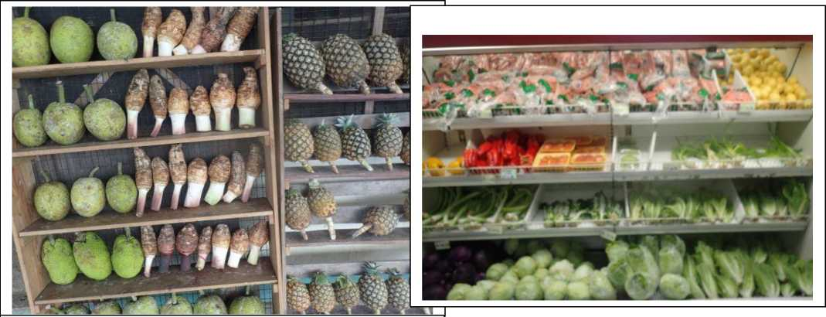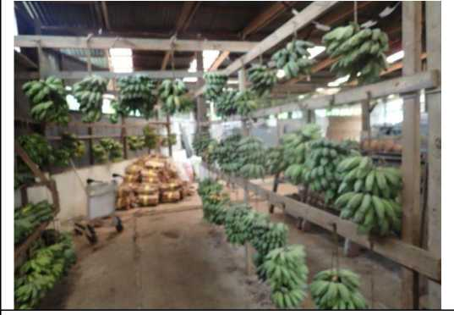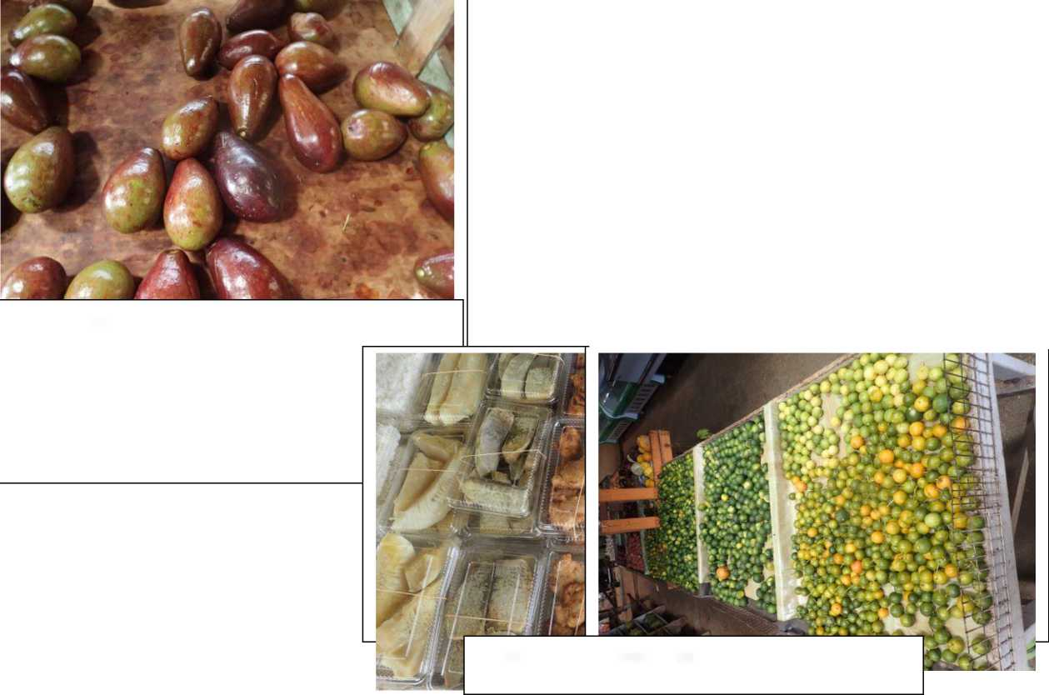

**Yap Markets**

**Yap Supermarket**

Neem *Oil*

Yap Chinese farm producing beans

Neem Oil sold in Yap hardware store

Chuuk

Chuuk Market

Col

60

Roadside Market

Boats bringing produce from the lagoon islands

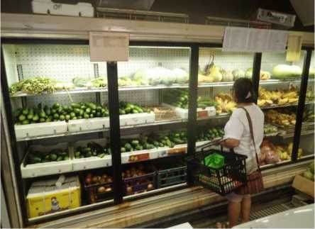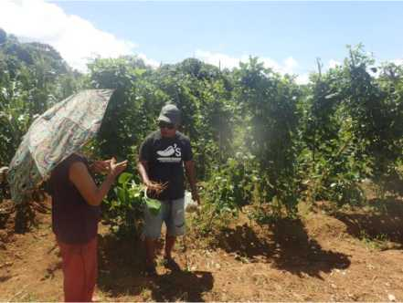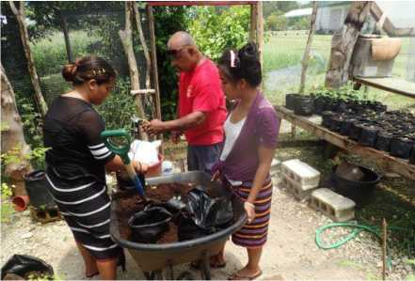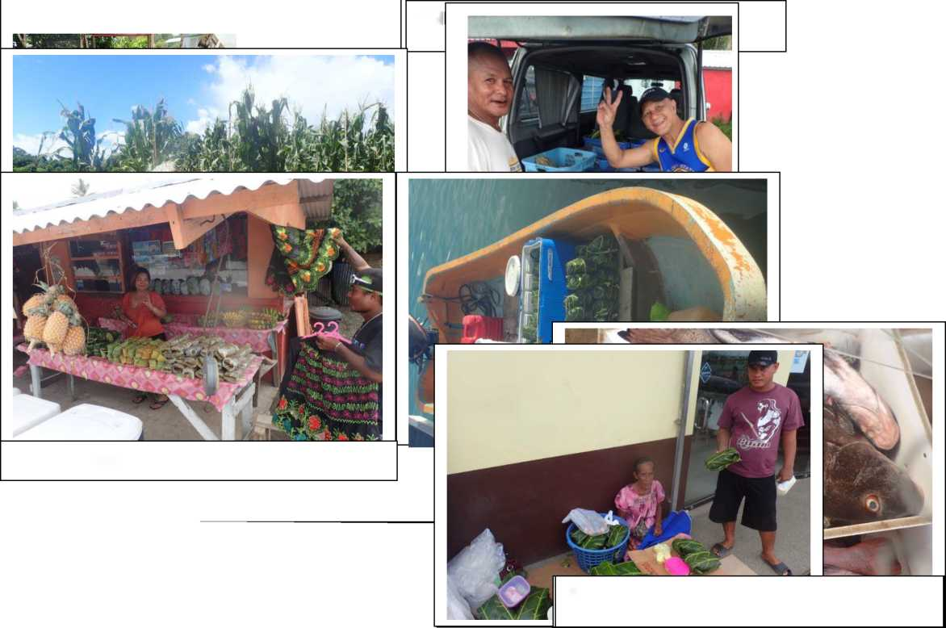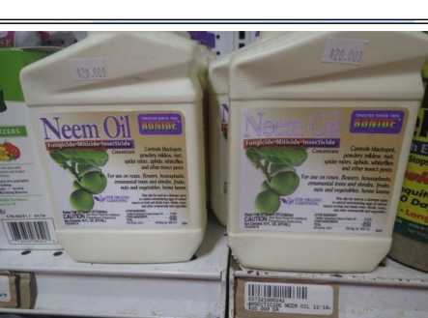

RJ Store

Kosrae Markets

RJ Store is the largest local agricultural market on the island, supplied primarily by Finaunpes Farms, selling over 5,000 lbs of farm produce, nearly 1,000 pounds of marine products and $10,750.00 in value-added product sales in the month of June 2019*.

Value added products from Kosrae exhibit

*Colocasia esculanta* is the predominant taro variety — ■ _ l_ I .

Shredded and frozen raw Taro, Tapioca (Cassava) and sprouted coconut are big favorites for consumption on the island, primarily for convenience, taste and as cultural staples.

both excellent livelihood opportunity and thus room for additional support and growth.

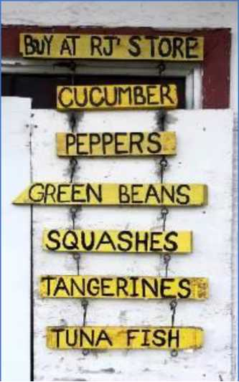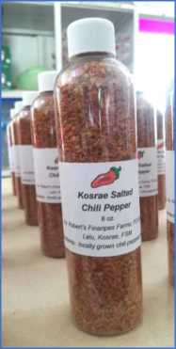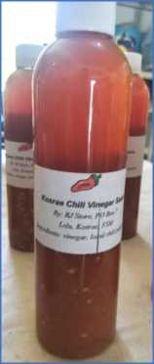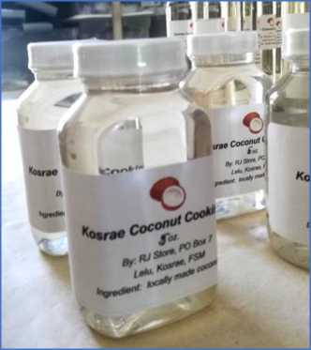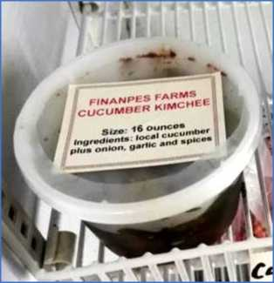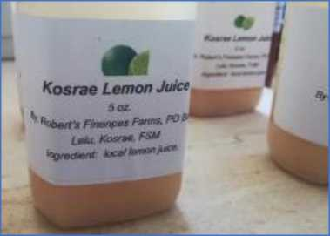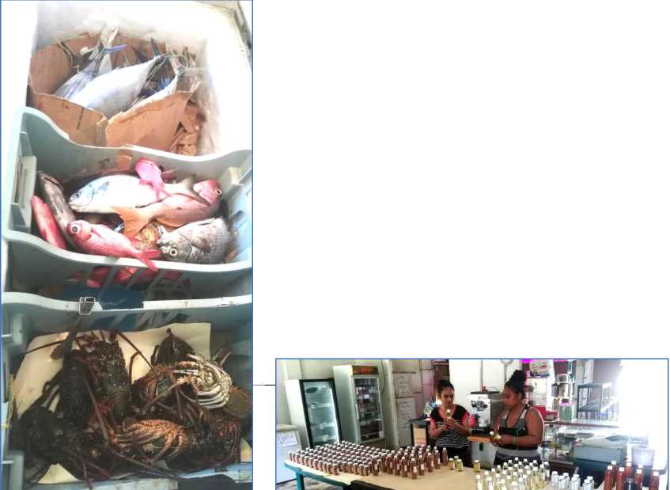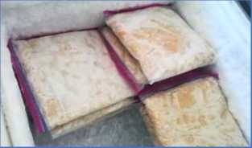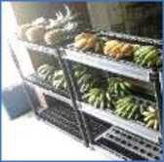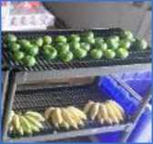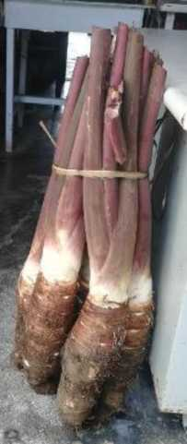

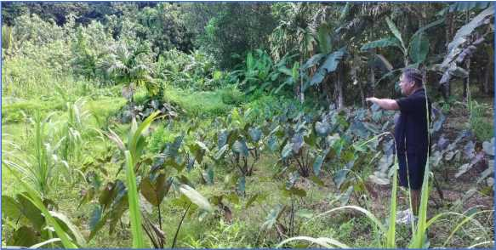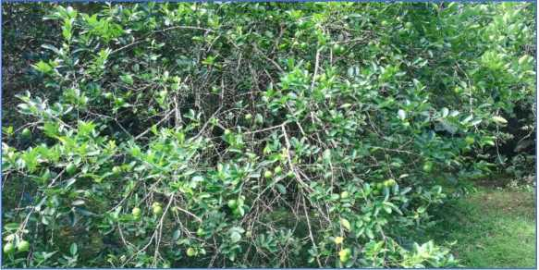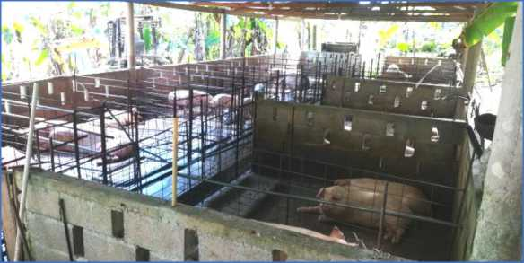

PMW Farm and Market

PMW Farm and Market is potentially the largest single landholding dedicated to commercial scale farming. From the period 2011-2016, the farm was producing large quantities of local produce (mostly cabbage and cucumber) mostly for export to the Marshall Islands. During this period, PMW constituted over 85% of total agricultural exports from Kosrae in what was a nearly $12,000 per year fledgling export industry*.

For the domestic market PMW also was providing significant local egg production, producing 150 dozen eggs locally per day at one point, as well as raising and selling ducks.

However, in early 2017 an illness befell the principal director and owner of the farm and vegetable production has given way to a focus on more long term, less labor intensive crops such as bananas, coconuts, taro, limes, oranges, tangerines, cassava, yam, Kalamansi, papaya, pineapple and some value added products.

PMW also maintains a commercial piggery with current plans for expansion. PMW roasts or ‘ums’ 6-7 pigs per month for sale and delivery to various island and family functions.

Additionally, as PMW continues to ramp up its current farming area and production of the local crops and produce noted above, they also are building infrastructure to make a significant investment in the coconut industry in FSM by planting 3,000 - 5,000 new coconut trees in the next 12-24 months.

*Source: Summary of DREA Coordinated Exports, FY11-FY17.

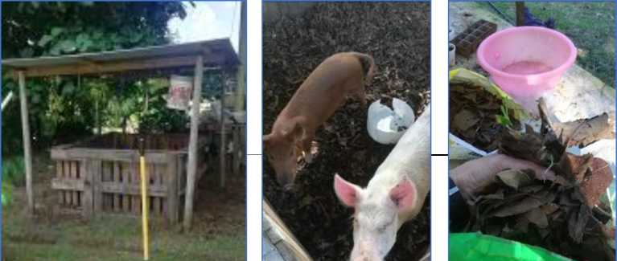KWF has recently implemented a new project on Kosrae where a component includes what is termed the Portable Dry Litter Piggery. The Dry Litter technology is simple to construct, easy to maintain, and inexpensive. The objectives of this newly introduced technology to Kosrae are three-fold: 1) mitigate pig effluent into the environment, 2) create a local fertilizer for enhanced food production supporting alternative income generation, and , ■ ■ ■

Women in Farming Kosrae

Wawa Chips

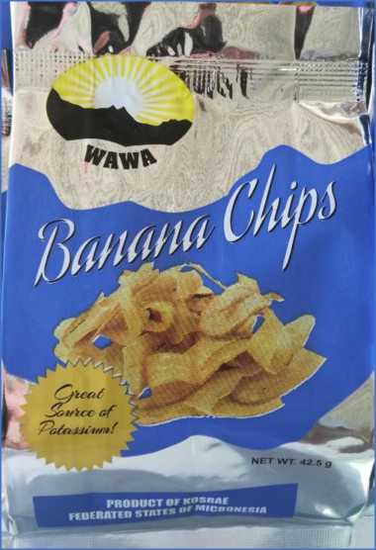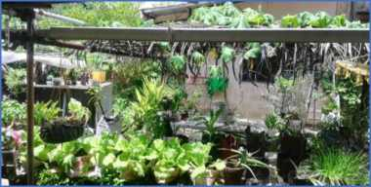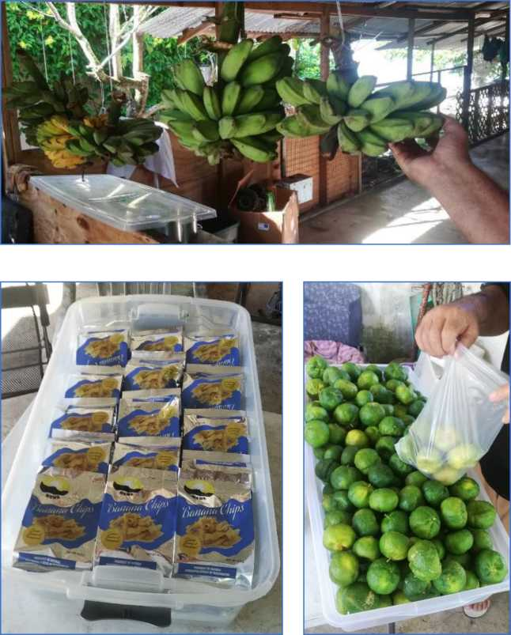

Wawa Chips is a small but modestly successful family operation that employs five people and works with low- income farmers from all over the island. The operation purchases and processes approximately 230 pounds of Manila bananas per month, known locally as ‘*Kafafafusus'.* It has been in operation since 2014 and has been supported by the Secretariat of the Pacific Community (SPC) through a European Union (EU) funded program, Increase Agricultural Commodities Trade (IACT). The family and its suppliers have plans to increase production of its Kafafa chip line, as well as introduce breadfruit chips, and quite importantly, to also produce chips from a rare and nearly obsolete banana variety on Kosrae known as ‘ *Kulasr*', a variety more widely known and celebrated for its extreme health benefits on Pohnpei as ‘ *Karat*'. Additional added value products such as the well-liked Kosraean pies and turnovers are made and sold with the bananas that become too ripe for chip production so that there is zero waste in the process. The operation also sells around 160-200 pounds of tangerines per month, largely to business travelers, tourists and airline crews at the Kosrae International Airport.

Sunrise Market

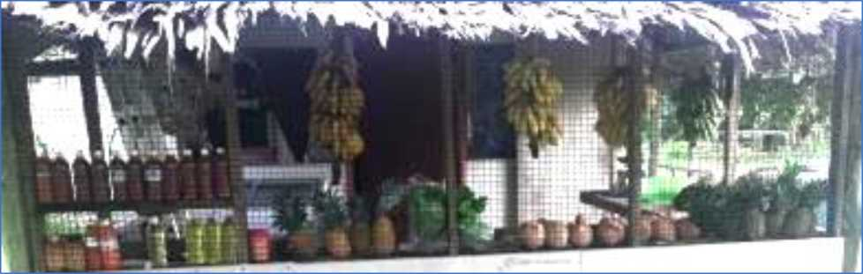

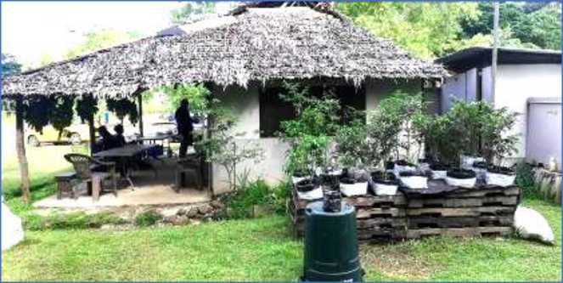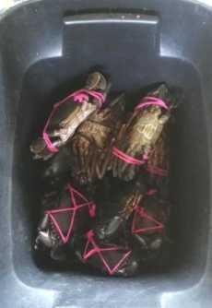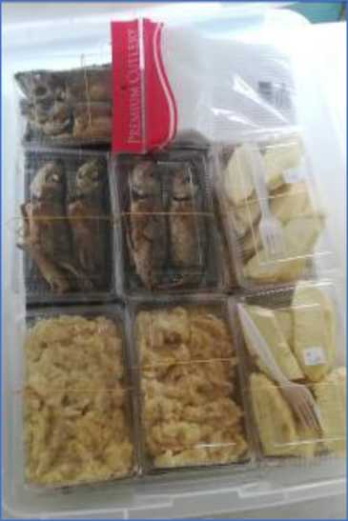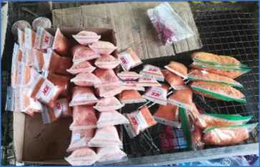

Sunrise Market is a local market with considerable daily activity, owing to its central location in the middle of the commercial and government center of Tofol, on Kosrae. Sunrise purchases and sells a large range of agricultural and marine products from farmers all over the island, including many local crops (bananas, papayas and pineapples) and fruits and vegetables (watermelons, cucumbers and cabbage). It also sells a multitude of value added and prepared products, including the popular salt-chili pepper mix, coconut body and cooking oils, vinegar-pepper and shredded and frozen raw Yam, Taro, Tapioca (Cassava) and sprouted coconut items.

Lelu Farmers Association

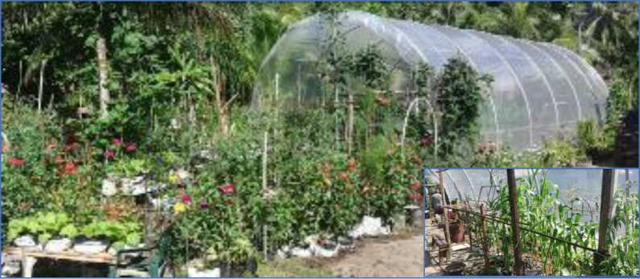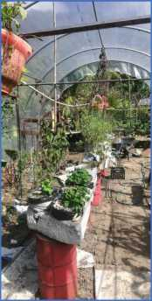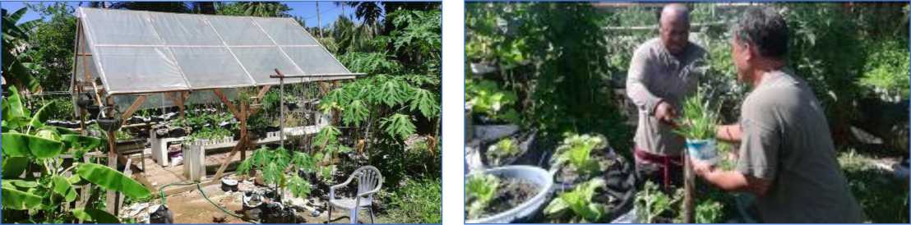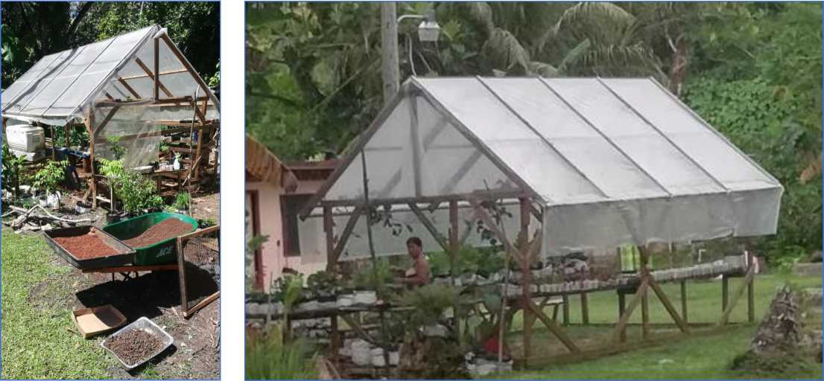

The Lelu Farmers Association (KFA) is one of the other active farmers groups on Kosrae, with an ongoing project to support farmers from each of the municipalities of the island. This project - co-funded by grants from the USDA and the Micronesia Small Grants Program (GEF) - has provided a significant boost to income generating opportunities to families and farmers, with the construction and provision of green houses, seeds, tools, imported fertilizer, bags and ongoing technical support and materials. Pictured above are greenhouses from around the island. Participants sell their produce to walk-in buyers from their communities, to local businesses, at monthly Farmers Markets, as well as **4-„ j-i £ : I u— 4-1 4. j I, -4. 4.1 1/ n u** a **:_4.., _£ 4.-LI : 1 1:**

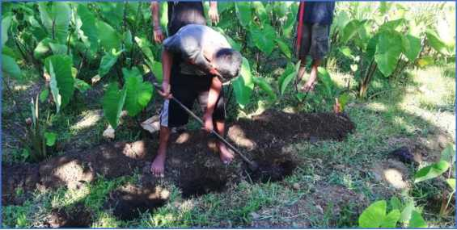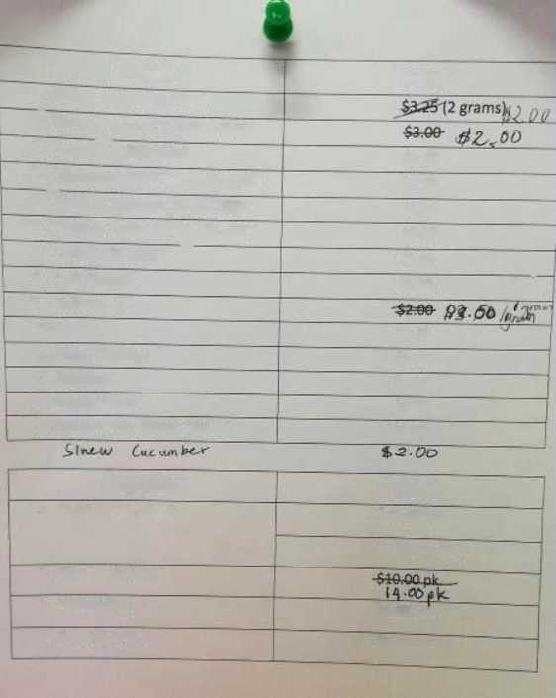

Other Activities in the Sector

12.Eggplant

13.Green Onion

14.Balsam Pear (Bitter Melon)

8. Chili Pepper

9. Bell Pepper

10.Beans

ll.Head Cabbage

$1.50

$1.50

$2.00

Seeds

4. Jucumber (PRETTY SWALLOW)

5- Chinese Cabbage (SALADEER)

6. Chinese Cabbage (VANGUARD)

7. Tomato (RAMGO) ~

Prices

$3.00

$2.00

$2.00

$0.85

$2.00

$2.00

$1.00

$1.50

1.

2?

3.

Water Melon (GLORY)

Watermelon (CHAMPAIGNE) Cucumber (SOARER)

Supplies

Prices

1. Fertilizer 16-16-16

$40.00 bag

$1.00 per lbs.

2. Chicken Manure

3. Polycel Bag

4. Cucumber Net

$2.50 ea.

$0.50 ea.

A recent training by the US Small Business Development Center program in FSM on expanding capacity on value added products - these provide a much higher return to farmers, with just a little more effort on their farms.

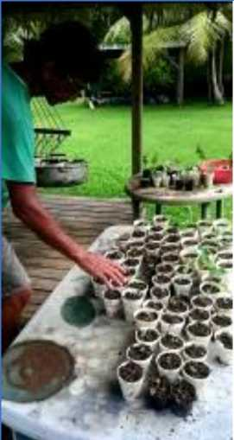The hotels on Kosrae maintain their own nurseries and gardens and also purchase from farmers many of the fresh vegetables required for their restaurants, owing to the increasing demand locally for a healthy diet inclusive of 6

vegetable fiber and protein.

Young boys in the village of Malem expand a small garden of soft taro. This is a popular variety known locally as ‘Kotaro’. This highlights the prevalence of agriculture activity on Kosrae.

The Department of Resources and Economic Affairs (DREA), Office of Agriculture, maintains a healthy stock of tropical seeds, farming inputs and materials for sale to farmers on the island at fair prices.

1. IMF, 2012
2. The 2010 Population Census results indicate that the population has fallen from 107,000 in 2000 to 103,000 in 2010. This fall is largely attributed to emigration.
3. *Number of Private Business Establishments by Type and Municipal Government, 1999-2018*, as provided by Kosrae State Office of Statistics 29 July 2019.
4. Interview with Farmer, Mr. Morris George on July 27, 2019. Mr. George is the gentleman on the cover of this report accepting payment for an Aloe Vera plant he produces, which is popularly used for medicinal purposes on Kosrae.
5. Cooked banana, mashed ripe banana with coconut milk, fried fish, fried eel, cooked and sliced breadfruit, and taro with coconut milk are some of the items observed by this researcher.
6. This includes the sought-after tangerine in Kosrae, where there was a significant decline in production when the white fly was introduced to the island and a commensurate export production decline in relation to the high demand of tangerine specifically, and Kosraean citrus more generally.
7. $18,535 in 2016, $12,124 in 2017 and $2,571 in 2018.
8. The above information is from the website of the FSM Statistics Division. The IFAD Consultant is questioning the correctness of the above data.
9. Implemented by the FSM Petroleum Corporation, operating as Vital Energy, it is known as the ‘Coconut for Life’ program, and seeks to produce large scale quantities - relatively speaking - of high value, food grade products such as Virgin Coconut Oil, Copra Meal, Coco Water and other value added byproducts.
10. A more complete picture of the company’s intervention into the industry to support farmers throughout the Federation can be found here: [https://www.vitalenergy.fm/faqs/.](https://www.vitalenergy.fm/faqs/)
11. Information supplied by Chuuk Statistics.
12. Winipat at 442 meters, Finkol at 634 meters and Nanlaud at 942 meters above sea level.
13. Whitesell et al., 1987;<http://archive.unu.edu/unupress/unupbooks/80824e/80824E0f.htm>
14. The current FSM Rapid Market Survey undertaken by Konrad and Wortel indicates that the number of pounds of agricultural being sold in the local markets on an annual basis amount to just under 5,000,000 pounds: 2,810,042 for Chuuk; 1,068,180 for Pohnpei; 627,166 for Yap; and, 433,091 for Kosrae. Divided by the total populations of each island you obtain these per capita numbers: Kosrae 65.5 lbs, Chuuk 57.8 lbs, Yap 55.1 lbs and Pohnpei 29.5 lbs.
15. This exhibition takes place at the Pacific Pavilion and has upward of 20,000+ visitors per day from April to October.
16. Importantly, China has a significant history of supporting agricultural productivity and values in FSM. The establishment of the China Pilot Farm in Pohnlangas, Pohnpei in 1998 was a major step forward in terms of introducing new vegetable foods into the local diet, and more importantly, visually showing how to do sustainable, tropical farming.
17. Luen Thai has the largest fishing fleet in the Pacific.
18. Finaunpes Farm, in Lelu, is a considerable operation and is currently quite active. The proprietor of the farm is also the Chairman of the Lelu Farmers Association. PMW Farm, in Malem, has a considerable holding of land and might, under the right circumstances, once again become the largest exporter of vegetables from Kosrae. Both farming operations should continue to be supported by government and non-government partnerships.
19. During the week of the rapid market survey, the store introduced a new product: Kosraean Crushed Chili. Dry and flakey with the hot pepper seeds mixed in, it proved quite perfect for the sashimi mahi-mahi we ate by the beach in the afternoon, along with the hand-squeezed lemon juice from the store.
20. The late Dr. Louise Englberger largely led the Karat banana back from obscurity in the early 2000’s and made it an internationally known and researched variety.
21. Source: Summary of DREA Coordinated Exports, FY11-FY17. See **Table 5** above for total exports during this period.
22. This researcher did not place an emphasis on pest data collection for Kosrae. However, in all the farms and greenhouses observed, he did not notice a significant incidence or hear from any of the farmers about pest problems. As such, I cannot also state with certainty that the LFA project is not utilizing pesticides or herbicides - though considering the provenance of the grant funds (GEF), it is not likely. Testimony from multiple farmers also stated that *Mr. Konrad Englberger* in fact had assisted the island in ridding the island of the highly problematic ‘white fly’ that appears now very much under control.
23. The tropical Hibiscus rosa-sinensis is a popular candidate for chipping in that it grows fast, is considered a pest and is a soft wood.